**Lowell Elementary**

**Emergency**

**Operations**

**Plan**

5010 West View Drive

Everett, WA 98203



Revised: 7/9/21

**TABLE OF CONTENTS**

**School Plan**

**I. INTRODUCTION** 1

A. Purpose of the Plan

B. Scope of the Plan

C. Situation Overview

D. Planning Assumptions and Limitations

**FUNCTIONAL AND THREAT/HAZARD-SPECIFIC ANNEXES**

Master Schedule Annex 5

Special Needs Students & Staff Annex 6

Building Map Annex 7

Emergency Equipment Annex 8

* Emergency equipment list
* Classroom safety backpack

Evacuation Annex 9

* Fire and fire drills

Lockdown Annex 14

Shelter in Place Annex 16

Accounting for All Persons Annex 19

Earthquake Annex 20

Severe Weather Annex 21

* Abbreviated schedule/early closure
* Release of students

Natural Disaster Annex 23

Bomb Threat Annex 24

Chemical Spill/Gas Leak Annex 28

Public Health, Medical, and Mental Health Annex 29

Controlled Student Release Annex 30

Communications and Warning Annex 31

* School phone tree
* Procedure for reporting emergencies
* Blackboard Connect instructions

**District Reunification**

**II. INTRODUCTION AND PURPOSE** 36

**FUNCTIONAL AND THREAT/HAZARD-SPECIFIC ANNEXES**

Reunification Annex 37

**Incident Command**

**III. CONCEPT OF OPERATIONS** 46

A. National Incident Management System

B. Implementation of the Incident Command System

C. Initial Response

D. Notification Procedures

E. Training and Exercising the Plan

F. Emergencies Occurring During the Summer or Other Breaks

**IV. ORGANIZATION AND ASSIGNMENT OF RESPONSIBILITIES** 49

**V. DIRECTION, CONTROL, AND COORDINATION** 50

A. School Incident Command System

B. Coordination with Policy/Coordinating Group

C. District Emergency Operations Plan

D. Source and Use of Resources

**VI. ADMINISTRATION, FINANCE, AND LOGISTICS** 51

A. Agreements and Contracts

B. Reports

C. Records

D. Preservation of Records

E. Consumer Protection

F. Post-Incident and Exercise Review

**VII. PLAN DEVELOPMENT, MAINTENANCE AND DISTRIBUTION** 53

A. Approval and Dissemination of the Plan

B. Plan Review and Updates

**VIII. AUTHORITIES AND REFERENCES** 54

**FUNCTIONAL AND THREAT/HAZARD-SPECIFIC ANNEXES**

Incident Command System Annex 55

* Organizational chart
* ICS job responsibilities

Continuity of Operations (COOP) Annex 76

* School emergency food usage plan

Recovery Annex 80

Security Annex 81

**School**

**Plan**



|  |
| --- |
| **I. INTRODUCTION** |

**A. Purpose of the Plan**

The purpose of the Emergency Operations Plan (EOP) is to identify and respond to incidents by outlining the responsibilities and duties of the school and its staff. Developing, maintaining, and exercising the plan empowers staff in an incident to act quickly and knowledgably. In addition, the plan educates staff, students, and other key stakeholders on their roles and responsibilities before, during, and after an incident. This plan provides parents and other members of the community with assurances that the school has established guidelines and procedures to respond to incidents/hazards in an effective way.

The developed guidelines and procedures for dealing with existing and potential student and school incidents are defined in the plan below. The basic plan and the functional and threat/hazard-specific annexes outline an organized, systematic method to mitigate, prevent, prepare for, respond to, and recover from incidents. Staff have been trained to assess the seriousness of incidents and respond according to these established procedures and guidelines.

**B. Scope of the Plan**

This EOP outlines the expectations of staff; roles and responsibilities; direction and control systems; internal and external communications plans; training and sustainability plans; authority and references as defined by local, State, and Federal government mandates; common and specialized procedures; and specific hazard vulnerabilities and responses/recovery.

1. Definitions

Incident: An incident is an occurrence–natural, technological, or human-caused–that requires a response to protect life or property. The principal or designee shall have the authority to determine when an incident has occurred and to implement the procedures within this EOP.

Hazards: Hazards shall include situations involving threats of harm to students, staff, and/or facilities. Hazards include but are not limited to natural, technological, and human-caused incidents. Hazards may require an interagency response involving law enforcement and/or emergency services agencies depending on the size and scope of the incident.

**C. Situation Overview**

1. School Population

a. General Population

Lowell Elementary School’s current enrollment is approximately 610 students located in 1 buildings on campus and 8 portables. These students are supported by a committed staff consisting of:

* 44 Teachers and specialists
* 2 Administrators
* 4 Office/support staff
* 26 Paraeducators
* 3 Cafeteria staff
* 2 Maintenance and custodial staff

A master schedule of where classes, grade levels, and staff are located during the day is provided to each classroom and is available in the main office. Refer to the *Master Schedule Annex* as a reference.

b. Special Needs Population

Lowell Elementary School is committed to the safe evacuation and transport of students and staff with special needs. The special needs population includes students/staff with (LIST SPECIFIC):

* Limited English proficiency,
* Cognitive or emotional disabilities,
* Mobility/ physical disabilities (permanent and temporary), and
* Medically fragile health (including asthma and severe allergies).

The school’s current enrollment of students with special needs is approximately 31 ; however, this number will fluctuate. Students and/or staff may require additional assistance if they are temporarily on crutches, wearing casts, etc.

The list of students and staff names with special needs along with their schedules can be found in the *Special Needs Students and Staff Annex*. Staff members that have been trained and assigned to assist the special needs population during drills exercises, and incidents are listed.

2. Building Information

Lowell Elementary School is located on a 9.34-acre lot and includes 1 buildings, and 8 portables. All classes take place in the main building campus and 8 portables.

A map of the buildings annotated with evacuations, shelter locations, fire alarm pull stations, fire hydrants, fire extinguishers first aid kits, hazardous materials storage, and utility shutoffs is included in the *Building Map Annex*. All staff members are required to know these locations as well as how to operate the utility shutoffs.

3. Hazard Analysis Summary

Lowell Elementary School is exposed to many hazards, all of which have the potential for disrupting the school community, causing casualties, and damaging or destroying public or private property. Hazards include:

Site hazard – Freeway (I-5).

Regional hazards – Not aware of any regional hazards.

4. Preparedness, Prevention, and Mitigation Overview

Preparedness is achieved and maintained through a continuous cycle of planning, organizing, training, equipping, exercising, evaluating, and taking corrective action. Ongoing preparedness efforts require coordination among all those involved in emergency management and incident response activities. The school fosters preparedness at all levels including students, parents, teachers, and staff. Examples of preparedness actions include maintaining this plan, conducting training, planning and implementing drills and exercises, etc.

Prevention includes actions to avoid an incident or to intervene to stop an incident from occurring. The school is committed to taking proactive prevention measures whenever possible to protect the safety and security of students and staff. Our policies include zero tolerance for bullying and other actions that undermine the safe haven of our school. Recent upgrades to security systems offer greater protection of our students. In addition, the school requires all adults to display identification badges.

Mitigation includes activities to reduce the loss of life and property from natural and/or human-caused disasters by avoiding or lessening the impact of a disaster and providing value to the public by creating safer communities. The school has taken action to reduce or eliminate the adverse effects of natural, technological, and human-caused hazards on people and property.

For example, of the many hazards that can endanger a school facility and its service to the community, the most prevalent is fire. The school was built in accordance with State building codes, in the form of approved materials, fire-resistant assemblies, exiting requirements, the width and design of stairs, the dimensions of corridors, fire suppression systems, and many other standards.

**D. Planning Assumptions and Limitations**

1. Planning Assumptions

Stating the planning assumptions allows the school to deviate from the plan if certain assumptions prove not to be true during operations. The EOP assumes:

* The school community will continue to be exposed and subject to hazards and incidents as described above, as well as lesser hazards and others that may develop in the future.
* A major disaster could occur at any time, and at any place. In many cases, dissemination of warning to the public and implementation of increased readiness measures may be possible; however, some emergencies occur with little or no warning.
* A single site incident (e.g., fire, gas main breakage) could occur at any time without warning and the employees of the school affected cannot, and should not, wait for direction from local response agencies. Action is required immediately to save lives and protect school property.
* Following a major or catastrophic incident, the school may have to rely on its own resources to be self-sustaining for up to 72 hours (See the School Emergency Food Usage Plan in the *Continuity of Operations (COOP) Annex*).
* There may be a number of injuries of varying degrees of seriousness to staff and/or students. Rapid and appropriate response will reduce the number and severity of injuries.
* Outside assistance from local fire, law enforcement, and emergency managers will be available in most serious incidents. Because it takes time to request and dispatch external assistance, it is essential for the school to be prepared to carry out the initial incident response until responders arrive at the incident scene.
* Proper prevention and mitigation actions, such as creating a positive school environment and conducting fire inspections, will prevent or reduce incident-related losses.
* Maintaining the EOP and providing frequent opportunities for stakeholders (staff, students, parents, first responders, etc.) to exercise the plan can improve the school’s readiness to respond to incidents.
* A spirit of volunteerism among school employees, students, and families will result in their providing assistance and support to incident management efforts.

2. Limitations

It is the policy of Everett Public Schools that no guarantee is implied by this plan of a perfect incident management system. As personnel and resources may be overwhelmed, each school can only endeavor to make every reasonable effort to manage the situation, with the resources and information available at the time.

|  |
| --- |
| **Master Schedule Annex** |

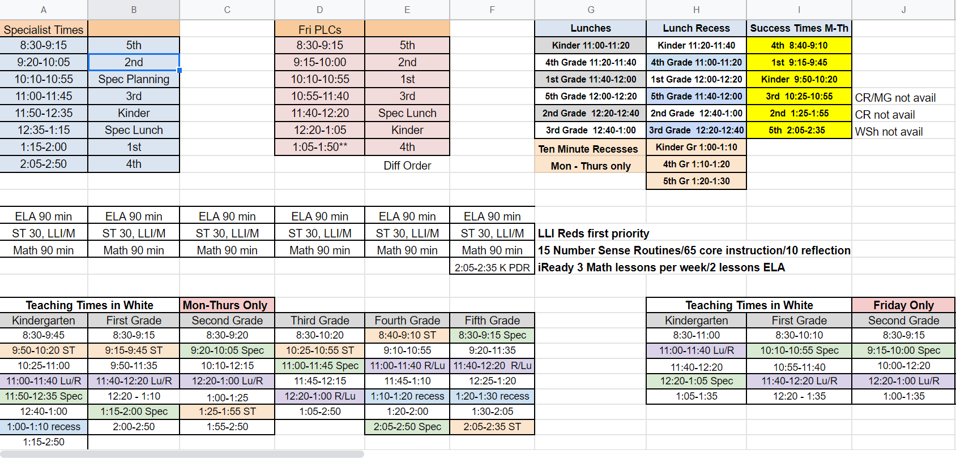

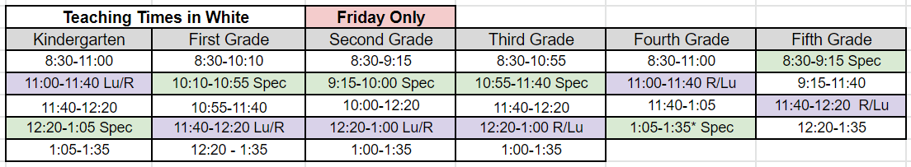

|  |
| --- |
| **Special Needs Students and Staff Annex** |

Teachers              4              Preschool, Life Skills and Resource Room

Paras                     8              Preschool, Life Skills and Resource Room

Students              31           Preschool and Life Skills

|  |
| --- |
| **Building Map Annex** |

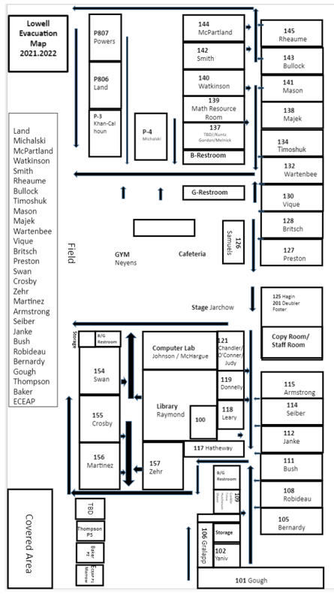

|  |
| --- |
| **Emergency Equipment Annex** |

**Classroom Safety Backpack Contents List**

* Metal Whistle
* Duct Tape (1 Roll)
* 50 Foot Utility Cord
* Small First Aid Kit
* Small EMT Multi-Use Scissors
* Letter Size Clipboard
* Writing Pad - Letter Size
* Ball Point Pen - Blue Stick
* Light Stick - Green 12 Hour (4)
* 4 Ounce Hand Sanitizer (2)
* Toilet Paper (1 Roll)
* Large Disposable Nitrile Gloves (2 Pair)
* Emergency Survival Blanket - 84" x 52" (3)
* 8 x 10 Blue/Green Tarp
* Garbage Bags - 30 Gallon (6)
* Safety Vest - Orange Mesh Reflective w/Pocket
* Shock Resistant Flashlight
* AA Batteries (4)

|  |
| --- |
| **Evacuation Annex** |

**Evacuation Procedures**

The Incident Commander Shall:

1. Evacuate to the designated area (site emergency map) bringing a bullhorn and a two-way radio for communication.
2. Obtain an accurate head count of all staff and students.
3. Identify missing individuals and their likely location.
4. Contact the regional deputy/assistant superintendent.
5. Provide details to the fire or police department when they arrive on the scene.
6. Coordinate with the fire or police department until the emergency is over.
7. Ensure students are returned to their classrooms or dismissed according to established student release procedures, as the regional deputy/assistant superintendent deems necessary.

Office and Custodial Staff Shall:

1. Check for students in the restrooms, gym, commons and nurse’s station in administrative areas.
2. Evacuate with two-way radios to the safe dispersal area.
3. Act as runners between the site administrator and teachers, to communicate information on missing individuals and emergency information.

Itinerant Staff Shall:

1. Secure their work areas from immediate hazards (i.e., powering down, closing valves, etc.).
2. Evacuate to the dispersal area.
3. Provide assistance as assigned by the principal or his/her designee.

General Education Teachers Shall:

1. Check to see if the primary evacuation route is safe and clear. If primary route is not accessible, use the secondary route.
2. Collect all students and Teacher Response supplies expeditiously from the classroom and area restrooms and evacuate in an orderly fashion to the safe dispersal area.
3. Upon arrival at the assembly point, line up the students and perform a roll call.
4. Convey the results of the roll call and report the names and likely locations of any missing individuals to the designated runner.
5. Supervise students during the emergency evacuation procedure.
6. Wait for the signal to return to the classroom, or further instructions for campus dismissal.
7. Non-special-needs teachers shall aid in the evacuation of visitors and students who are temporarily mobility-impaired (i.e., on crutches, etc.).

**Evacuation Annex**

Special-Needs Teachers Shall:

1. Check to see if the primary evacuation route is safe and clear. If primary route is not accessible, use the secondary route.
2. Collect all students expeditiously from the classroom and restrooms.
3. Assign evacuation assistant duties to para educators and other trained staff members for the students under their supervision. The special-needs teacher shall ensure that two adults shall be assigned to each mobility-impaired student.
4. Evacuate in an orderly fashion to the safe dispersal area.
5. Upon arrival at the assembly pint, line up the students and perform a roll call.
6. Convey the results of the roll call and report the names and likely locations of any missing individuals to the designated runner.
7. Supervise students during the emergency evacuation procedure.
8. Wait for the signal to return to the classroom, or further instructions for campus dismissal.

Para Educators and Trained Staff Shall:

1. Provide assistance as instructed by the primary and secondary special needs teachers.
2. When assigned to the first floor, wheel special-needs students in wheelchairs to the evacuation area.
3. When assigned to the second floor, assist in carrying students in wheelchairs down the stairs to the dispersal area. If needed, two adult assistants may be assigned for one wheelchair-bound student.
4. Provide assistance to non-mobility impaired special-needs students by being a “buddy.” This activity requires holding the hand of the individual and guiding them down the stairs. These students are not mobility impaired and only need a firm hand to lead them.

Students Shall:

1. Follow instructions of teachers and support staff during emergencies.
2. When willing and physically able, be assigned to assist special-needs students during evacuation. Duties may include:
   1. Act as a “buddy” to assist non-mobility impaired students to safe dispersal area.
   2. Assist temporarily mobility impaired students on crutches as described in the following section.

**Mobility-Impaired Visitors**

Visitors needing help and students who are temporarily mobility-impaired (i.e., on crutches, etc.) shall be assisted by trained staff during an emergency. Teachers, office, library, and custodial staff shall be trained to assist in the evacuation of these individuals.

**Evacuation Annex**

**Fire and Fire Drills**

In the Event of a Fire

* Give the fire alarm signal (one long continuous signal).
* Call and report the fire (911).

Authority to sound the fire alarm system in the event of a real emergency is possessed by ANY PERSON who discovers the fire.

Principal/Administrator Responsibilities

* Sound the alarm.
* Call and identify self to fire department officials, directing them to the location of the fire and give them any necessary special information.
* Make a building search.
* Ensure that students and teachers perform all activities assigned to them during fire drills.

Fire Drills

* Instruction must be given to all students on the FIRST DAY of school each year.
* A fire drill should be held within the first ten days of school and as frequently as may be necessary to assure rapid and orderly evacuation.
* It is particularly important that kindergarten children, representing the one large group of children new to the schools, be given instructions in fire drill procedures for the building.

Authority to Call Drills

The sound of a fire alarm for the purpose of a drill is an authority possessed solely by the principal, or someone authorized by him/her.

Purpose of Fire Drills

Fire drills are held to familiarize the occupants of a building with the signals, evacuation routine, and exits so that in case of emergency there shall be no hesitation or confusion in leaving the building.

These drills are for the safety of all persons involved, and each person must realize that the success of the drill is dependent upon his/her actions and cooperation. Therefore:

* All persons in the building must take part in the fire drill.
* Every fire alarm should be considered as a warning of an actual fire.

Frequency of Fire Drills in Schools

* Fire drills shall be held as often as necessary to assure rapid and orderly evacuation of the school building. During severe weather, fire drills may be postponed. A record of all fire drills shall be kept on the premises subject to inspection by the fire chief. All drills will be recorded in a timely manner in the Rapid Responder system.
* In schools, fire drills include complete evacuation of all persons from the building.

**Evacuation Annex**

Warning Signals ~ Fire Drills

The fire warning signal shall be one long continuous signal, whether by bell, siren or air horn.

An emergency warning signal, either by whistle, air horn or hand siren, should be planned for, and occasionally used, thereby anticipating possible power failure.

Principal/Administrator Responsibilities

* Be in complete charge of all matters pertaining to organizing and conducting fire drills in the building and shall be responsible for the efficiency of the drill and all corrective actions or punishments taken for violation of the rules and regulations.
* Be thoroughly familiar with the fire alarm system, all fire fighting equipment, all means of egress, and any special features of the building that might prove dangerous to human life (storerooms, lunchrooms, attic spaces, ventilators, etc.), or where fire may spread quickly.
* Be responsible for notifying custodians, engineers, and lunchroom staff that in case of an actual fire, the ventilating systems, the oil burners, gas meters, ovens, etc. are to be shut off.
* Appoint all subordinate officers (see below) and instruct them in the general plan of the drills and details of their specific duties, such as instruction regarding:
  + How to send an alarm to the fire department (including how the fire alarm system operates ~ both electrical and emergency).
  + How to use all in-school firefighting equipment.
  + The importance of quick action to send in a fire alarm signal, and to vacate the building ~ even if in-school firefighting equipment is in use.
    - Appoint subordinate officers:
* Searchers ~ These are teachers assigned to inspect sections of the buildings to make sure that everyone is out. Closets, lavatories, teachers’ rooms and all other places frequented by students or teachers must be checked. Searchers shall rejoin their classes as soon as the inspection is completed.
* Traffic Guards ~ These are students appointed by the Incident Commander to open doors, assist in traffic control and maintain order.
* Safety Coordinator ~ In case of actual fire, during the absence of the Incident Commander, it must be clearly understood by the entire staff which person shall be in charge.

Teachers/Staff Responsibilities

* Be in charge of their respective classes.
* Issue all commands relative to participation in the fire drills except as delegated by them to aides.
* Unless assigned as searchers, lead their classes to the designated outside stations.
* Immediately report to the Emergency Operations Center or fire drill aides, if any student is unaccounted for after a visual check of students.

**Evacuation Annex**

During Fire Drills

* Teachers shall lead students to the designated exit.
* Students shall walk briskly (no running), with arm’s length spacing, and without talking, laughing or breaking from the ranks. (No student may leave the line.)
* Students not in the classroom shall join the line of the first group of students met. (The student must not return to the classroom.)
* Teachers shall check roll when assigned area is reached.
* Teachers shall not leave the students gathered at a designated area unless someone is placed in charge.
* Teachers shall notify the Incident Commander if any student is missing.
* The principal shall initiate a search for any missing students.

After a Fire Drill

* The Incident Commander shall give the all clear signal (a short steady signal).
* Teachers shall lead the students back into the classroom.
* Teachers shall check the roll.
* Students shall not loiter in the halls.
* Teachers shall notify the Incident Commander if any student is missing.
* The Incident Commander shall initiate a search for any missing students.

After a FALSE ALARM, Principal/Administrator Responsibilities

* Notify the fire department of the incident.
* Notify school officials of the incident.

Drills on Request

Occasionally, fire department representatives may come to schools and request an immediate fire drill. In general, this is their method of checking upon the quality of the drill program. Incident Commanders are expected to cooperate fully, even to the extent of calling a drill at an inconvenient time.

|  |
| --- |
| **Lockdown Annex** |

**Lockdown Procedures**

The Site Administrator Shall:

1. Call the designated executive director.
2. Coordinate the securing of all doors and school access points.
3. Obtain an accurate head count of all staff and students.
4. Identify missing individuals and their likely locations.
5. Provide details to the police when they arrive on the scene.
6. Coordinate with Law Enforcement until the emergency is over.

Custodial Staff Shall:

1. Follow procedures as outlined in site emergency plan.

Itinerant Staff:

1. Secure their work area from immediate hazards.
2. If inside during a lockdown, close and lock doors, and close blinds.
3. If working outside during a full lockdown, leave site immediately. Notify department supervisor for additional directions.
4. If working outside during a modified lockdown, go inside and close and lock doors, and close blinds. Report presence to ICP. (Leaving during a police search in the vicinity of the school may throw off tracking dogs and district police resources.

Teachers Shall:

1. Round up all students directly outside classroom.
2. Lock door, close outside blinds. Interior blinds must also be closed.
3. Teachers shall maintain a calm atmosphere in the classroom, keeping alert to emotional needs of students.
4. Full lockdown students shall be instructed to get under desks and away from windows.
5. Modified lockdown students may function in classrooms but may not leave the building under any circumstances.

**A FULL LOCKDOWN IS ALWAYS ASSUMED UNLESS OTHERWISE NOTIFIED BY LAW ENFORCEMENT OR INCIDENT COMMANDER.**

Convey the results of the roll call and report the name and likely location of any missing individuals to the office if asked.

4. Wait for the all-clear announcement to end lockdown.

**Lockdown Annex**

Office, Educational Assistants and Other Staff Shall:

1. Provide assistance as instructed by the Site IC.
2. When assigned, collect information on head counts and likely locations of missing students.

All Staff and Students Shall:

1. Refrain from using remote controls, telephones, or radios during lockdown unless assigned by the Site IC or designee.
2. Go immediately to a Class I Lockdown (get under desks, lie on the floor and get away from windows and doors) if gunshots are heard.
3. **CAUTION:** If the fire alarm is activated during a lockdown, staff and students shall not evacuate unless evidence of fire (i.e., smoke, flames) is seen or smelled. (This may be a ploy to get students out in the open and make them vulnerable to assault.)
4. If students and staff are on the playground or on an athletic field during lockdown:
   1. If the intruder is on the playground or athletic field, staff and students shall be instructed to go to the cafeteria or gym.
   2. If the intruder is in the building, staff and students shall be directed to an alternative Parent/Student Reunion point.
5. If students are on a bus, they should drop and lie flat on the bus floor.

|  |
| --- |
| **Shelter-in-Place Annex** |

**Administrative Procedures**

“Shelter-in-place” is initiated to protect students and staff from chemical, radiological, or biological contaminants released into the environment. To “shelter-in-place” means to take immediate shelter where you are and isolate your inside environment from the outside environment.

|  |
| --- |
| **PREPARATION** |
| ◻ Staff and students receive annual training in “shelter-in-place” procedures.  ◻ “Shelter-in-Place” drills occur at least once annually.  ◻ Inventory classroom emergency equipment.  ◻ Assess classrooms and offices to determine which spaces are appropriate for sheltering use.  ◻ Identify alternate locations for students and staff in portables and gymnasiums.  ◻ Prepare written/pictorial instructions for shutting down heating and ventilation systems.  ◻ Train appropriate staff to shut down heating and ventilation systems.  ◻ Develop emergency communication protocols (especially use of email) and notification to outlying areas.  ◻ Determine a protocol for limiting student/staff cell phone use. |
| **RESPONSE** |
| ◻ Main office receives directive to “shelter-in-place”. May come from District office or emergency agency.  ◻ Administrator or designee closes the school, activates emergency plan, and assumes Incident Command role.  ◻ **COMMUNICATE “SHELTER-IN-PLACE” STATUS**: (notify remote buildings and outlying areas)  **“SHELTER IN PLACE. THIS IS NOT A DRILL”**  **“STAFF AND STUDENTS PLEASE MOVE TO YOUR SHELTER AREAS.”**  ◻ **ASSIGN RESPONSIBILITIES TO OTHERS:** (administrator remains in command center.)  ◻ **LOCK** all outside doors. Assign monitors.  ◻ **NOTIFY** area director.  ◻ **SWEEP** halls and non-classroom areas of students; move to nearest shelter room.  ◻ T**URN OFF** heating and ventilation systems, seal make-up air systems.  ◻ **MONITOR RADIO AND MAIN PHONE LINE.**  ◻ **REPORT** progress to district office.  ◻ **ASSESS NEEDS AND PROVIDE CARE:**  ◻ Contact each room to determine needs for first aid or other care.  ◻ **WAIT FOR INSTRUCTIONS OR INFORMATION:**  ◻ If instructed by officials, seal rooms as directed.  ◻ Update staff and students as information is received.  ◻ Work with the district Public Information Officer on a Connect-ED call to parents.  ◻ **GIVE “ALL CLEAR” SIGNAL** when safety of the environment has been assured.  ◻ Direct staff and students to exit the building.  ◻ Once building is clear, direct maintenance staff to re-start HVAC systems. |
| **RECOVERY** |
| ◻ **RESUME NORMAL OPERATIONS** as soon as possible.  ◻ Assess the need for aftercare, counseling, or Critical Incident Stress Debriefing.  ◻ **COMMUNICATE STATUS**:  ◻ Notify district office of any problems.  ◻ Email staff an overview of the situation to minimize misinformation.  ◻ Work with the district Public Information Officer to prepare a brief written communication to parents explaining the situation.  ◻ Debrief and evaluate with key staff, including First Responders.  ◻ **DOCUMENT and REPORT:**  ◻ Prepare a report that documents events, response, and results of the “shelter-in-place” directive. Revise response procedures as necessary.  ◻ Enter action in Rapid Responder. |

**Shelter-in-Place Annex**

**Classroom/Office Procedures**

“Shelter-in-place” is initiated to protect students and staff from chemical, radiological, or biological contaminants released into the environment. To “shelter-in-place” means to take immediate shelter where you are and isolate your inside environment from the outside environment.

|  |
| --- |
| **PREPARATION** |
| ◻ Review “shelter-in-place” procedures at least annually with your students; post sheltering guidelines.  ◻ Explain to students the reasons for “shelter-in-place”—answer questions and re-assure students  ◻ Inventory classroom emergency equipment; advise administration of needed equipment or supplies. |
| **RESPONSE** |
| ◻ **BECOME FAMILIAR WITH CAMPUS LOCATIONS.**  ◻ **IDENTIFY SHELTER SPACES.**  ◻ **RESPOND TO ALERT:** ***“SHELTER IN PLACE. THIS IS NOT A DRILL.”***  ◻ **MOVE** to your assigned shelter location with your students.  ◻ **SWEEP** any students in the hallway into your shelter room.  ◻ **LOCK** all exterior doors (lock exterior doors near your room.)  ◻ **CLOSE** windows.  ◻ **TURN OFF** any classroom heating or ventilation; cover air vents with plastic  ◻ Instruct students to stay calm. Share developmentally appropriate information.  ◻ Do not use the telephone system to request information (follow protocols for email.)  ◻ **ASSESS SITUATION:**  ◻ Inventory any injuries or other problems (panic, medical emergencies.)  ◻ Communicate problems to main office.  ◻ Take a complete written roll of all students in your classroom.  ◻ **CARE FOR THE STUDENTS IN YOUR SUPERVISION:**  ◻ **Provide first aid if needed. Calm and re-assure upset students.**  ◻ Use supplies in your emergency kit as needed or necessary.  ◻ Occupy students with activities, music, reading, etc. to reduce anxiety.  ◻ **WAIT FOR INSTRUCTIONS:**  ◻ Monitor email for updates from administration.  ◻ **WAIT FOR “ALL CLEAR” SIGNAL** or communications from command post or responders. Follow any instructions on exiting or ventilating the building. |
| **RECOVERY** |
| ◻ Assess the need for aftercare or counseling by students in your care.  ◻ Contact front office with names/numbers of students who may need counseling or aftercare.  ◻ **RESUME NORMAL OPERATIONS** as soon as possible.  ◻ Communicate only confirmed information to students (expect an e-mail from administrators.)  ◻ Participate in debriefing sessions. Provide feedback to administration to improve planning/response cycle.  ◻ Inventory and re-stock emergency supplies as needed. |

**Shelter-in-Place Annex**

**Maintenance/Custodial Procedures**

“Shelter-in-place” is initiated to protect students and staff from chemical, radiological, or biological contaminants released into the environment. To “shelter-in-place” means to take immediate shelter where you are and isolate your inside environment from the outside environment.

|  |
| --- |
| **PREPARATION** |
| ◻ Review “shelter-in-place” procedures at least annually with all maintenance staff; post instructions in work areas.  ◻ Explain to employees the reasons for “shelter-in-place.”  ◻ Inventory emergency equipment, including plastic and tape to seal rooms, doors, and HVAC systems; prepare pre-cut plastic sheets or prepare other means to seal HVAC systems. Assess the ability to shut off and seal HVAC systems and other exposures to the outside environment. Advise administration of needed equipment, supplies or maintenance.  ◻ Assist in the assessment to determine which spaces are appropriate for sheltering use. |
| **RESPONSE** |
| ◻ **RESPOND TO LOCKDOWN ALERT: “*SHELTER IN PLACE. THIS IS NOT A DRILL*.”**  ◻ **CLOSE AND LOCK** all outside doors and windows.  ◻ **SHUT DOWN** all HVAC systems and SEAL air intakes and exhausts.  ◻ **TURN OFF** any classroom heating or ventilation; cover air vents with plastic.  ◻ **SEAL** all exterior building openings which allow air intrusion.  ◻ **ASSIST** teachers and administrators with sealing remainder of building.  ◻ **ASSESS SITUATION:**  ◻ Inventory any major air intrusions and report to Incident Command.  ◻ Communicate other problems to Incident Command.  ◻ Document your actions, including times HVAC was shut down.  ◻ **CARE FOR THE STAFF or STUDENTS IN YOUR SUPERVISION:**  ◻ **Provide first aid if needed. Calm and re-assure upset staff or students.**  ◻ Use supplies in your emergency kit as needed or necessary.  ◻ **REASSESS SITUATION AND WAIT FOR INSTRUCTIONS:**  ◻ Reassess building sealing efforts and report problems to Incident Command.  ◻ Reseal doors and windows with plastic and tape if instructed to do so.  ◻ Monitor radio or email for communications.  ◻ **WAIT FOR “ALL CLEAR” SIGNAL** or communications from command post or responders. Follow any instructions on exiting or ventilating the building. |
| **RECOVERY** |
| ◻ Assess the need for aftercare or counseling by students in your care.  ◻ Contact front office with names/numbers of students who may need counseling or aftercare.  ◻ **RESUME NORMAL OPERATIONS** as soon as possible.  ◻ Communicate only confirmed information to students (expect an e-mail from administrators.)  ◻ **DOCUMENT and REPORT:**  ◻ Provide feedback to administration to improve planning/response cycle.  ◻ Participate in debriefing sessions.  ◻ Inventory and re-stock emergency supplies as needed. |

|  |
| --- |
| **Accounting for All Persons Annex** |

Plan the courses of action for accounting for the whereabouts and well-being of students, staff, and visitors, and identifying those who may be missing.

**The planning team should consider the following when developing goals, objectives, and courses of action:**

**INSERT YOUR PLAN FOR ACCOUNTING FOR ALL STAFF**

* **How staff will determine who is in attendance at the assembly area.**
* **What to do when a student, staff member, or guest cannot be located.**
* **How staff will report to the assembly supervisor.**
* **How and when students will be dismissed or released.**

**INCIDENT COMMAND SYSTEM ORGANIZATIONAL CHART**

**INCIDENT COMMANDER**

Cindy/Andre

**PUBLIC INFO OFFICER           SAFETY OFFICER LIAISON OFFICER**

Wayne, Renee Rob, Andre Judy, Shaver

**OPERATIONS           PLANNING/INTELLIGENCE LOGISTICS**

Ken, Emilee , Joe     Lisa O, Michelle               Mary Do, Hillary

**Site facility/check/security      Documentation             Supplies/Facilities**

Ken, Daniel              Doreen, Kerry/Cristie  Crystal, Brenda, Dana

**Search & Rescue         Situational/ Analysis             Staffing**

Grace, Cindy K , Cyrelle             Conklin, Nicole M                   Hillary, Hathaway, Hutchinson

**Medical Communication**

Nurse, Dave   Wayne

**Student Care**

Teachers with students

**Student Release**

Fritze, Padilla

**\*\*FINANCE/ADMINISTRATION-timekeeping, purchasing**

Wayne

** Assignment according to need and staff availability. Do not activate FINANCE/ADMIN section unless directed by the District.

|  |
| --- |
| **Earthquake Annex** |

All students shall be required to stay at school under the care and supervision of district personnel until released to their parents, legal guardians or an adult listed on the student’s authorized emergency contact list. Students on buses shall remain in the custody of the bus driver and shall, if possible, be delivered to a district school site for care and supervision.

**Staff and students shall:**

Stay calm; your students are depending on you!

1. If in a building:
   1. DROP, COVER AND HOLD. Face away from windows, and try to avoid glass and falling objects, move away from under suspended light fixtures. Get under desks, chairs or tables.
   2. After the earthquake stops, teachers shall make a quick assessment of the class and post on the doors, one of three communications cards kept in their “to go” box:
      1. Red ~ Urgent, injuries need immediate assistance.
      2. Yellow ~ Minor injuries, need assistance.
      3. Green ~ Everyone evacuated.
2. If students or staff are injured, the teacher shall hand off his/her class to his/her “buddy teacher” for evacuation and stay behind to render assistance.
3. The “buddy teacher” shall evacuate and request aid for those left behind.
4. The building assessment team shall check the building and evaluate if continued evacuation is warranted, or if re-occupancy may occur and report back to the site IC.
5. If outside on school grounds:
6. The teacher, or other person in authority, shall instruct students to DROP. The safest place is in the open. Stay there until the earthquake is over. Move away from buildings, trees, and exposed wires.
7. Remain in the open until a member of the building assessment team or runner advises that it is okay to enter the building.
   1. Students may be returned to classroom OR
   2. Wait in the gymnasium.
      1. On school bus (regular routes, field trips, etc.)
8. Students shall follow the directions of the bus driver. The bus driver is legally responsible for the welfare of student riders.
9. Driver is to contact district transportation for instructions.

**School administrative procedures:**

1. When appropriate signal evacuation of building by sounding alarm.

2. Assess damage and determine if any part of the school can be used as a shelter.

3. Activate school-based emergency ICS response teams.

|  |
| --- |
| **Severe Weather Annex** |

Severe weather is defined as weather conditions that are, or have the potential to be, dangerous to pedestrian and/or vehicular traffic and include: snow, ice, high winds (over 40 mph), extreme heat, and extreme rainfall.

**Procedure**

* Snohomish County Department of Emergency Preparedness will notify designated personnel at Everett Public Schools that severe weather conditions are imminent or forecasted.
* When severe weather warnings are received:
  + The superintendent/designee will notify the principals/administrators of the danger and/or warning.
  + The principals/administrators will notify students and staff in the most direct and expedient manner.
* Students and staff are to remain in the building and be kept away from windows. Interior hallways and lower floors are the safest in severe windstorms.
* In the event of damage and/or injuries, the site emergency plan will be activated, and personnel will assume emergency responsibilities as assigned/delegated.

**Procedure for Abbreviated Schedules or School Closure Due to Emergency Conditions (including hazardous weather).**

* Only the superintendent or his/her designee has the authority to alter the school or district office schedule. The superintendent’s designee(s) will act in his/her absence.

Abbreviated Day: The Superintendent, in consultation with the Executive Director of Facilities and Operations, Supervisor of Transportation and the Director of Maintenance and Operations, will determine if some or all schools should be closed or opened on an abbreviated schedule. Once a decision is made, the Executive Director of Facilities and Operations will initiate a communications plan to inform district staff, students, parents, community and local news media.

**Early Closures**

* In the event of a major emergency that may threaten the operation of several or all schools in the district, the superintendent or his/her designee will determine whether normal district (site) operations should be halted or should continue.
* Suspension of normal operations does not necessarily mean that the facility will be closed, but it may mean that normal school/office schedules are disrupted.

The superintendent or his/her designee will consult the Office of Emergency Preparedness where required, site administrators, appropriate agencies and district departments in making the decision to interrupt or continue normal operations.

**Reference**: Everett Public Schools [Policy 2223](http://docushare.everett.k12.wa.us/docushare/dsweb/Get/Document-356/2223%20School%20Closure.pdf) & [Procedure 2223P](http://docushare.everett.k12.wa.us/docushare/dsweb/Get/Document-431/2223P.pdf), School Closure

**Severe Weather Annex**

**Release of Students when Normal Operations are Interrupted**

In the event of an emergency (including weather related situations), when normal school operations are interrupted, all students (those who walk, drive or are transported by school buses) and staff will remain at the school site until normal release time unless the evacuation of an entire site is needed, in which case students and staff will be transported to a nearby district facility.

**Retaining Students at School**

* At the normal release time, the superintendent or his/her designee in consultation with site leaders, appropriate district departments and the County Office of Emergency Preparedness (if needed) will re-evaluate conditions and determine if students can be released and/or transported.
* Schools will have plans for adequate student supervision when students cannot be released at the normal time.
* Staff may be required to remain in emergencies when student supervision is necessary.
* Non-school administrators will be expected to assist schools in student supervision during such conditions.
* The Director of Communications or his/her designee will notify area broadcast media of the interruption of normal operations and student release procedures.
* Once a major emergency has been identified and announced to the public, parents, guardians or other authorized persons may pick up students before normal release time. Only those persons specifically identified on student records will be allowed to take students from school. School staff will keep records of all students who leave and to whom they were released.
* Decisions about after school activities will, when possible, be made by 1:00 p.m. on the day of the school delay or closure. The decision will be made by the Superintendent in consultation with the Executive Director of Facilities and Operations.

|  |
| --- |
| **Natural Disaster Annex** |

**Incident Flow for Natural Disaster**

1. *Classroom Teachers* comprise the **Student Care Team** and will stay with their students at all times following the established plan to evacuate building when instructed to do so. Absolute silence is required. Attendance will be taken and submitted.

2. **The Sweep Team** will clear the building and report the condition of the facility to the Command Post.

3. **The Command Post** will be established in the front of the main office. Any staff member who does not have an assignment will report to the Principal/Assistant Principal at the command post.

4. If students are unaccounted for, information will be gathered as to where they were last seen.

5. **Logistics Personnel** will oversee the distribution of supplies as directed by Mary Detloff/Mary Donelly. Mary Det/Don and available staff will assist in handing out supplies.

6. **Rescue Team** members (*Same as sweep team*) will retrieve their gear from the outdoor storage and look for missing students.

7. The **Medical Team** will retrieve their supplies from the storage box and establish a medical post in a safe area (on field/in-building (cafeteria/gym). Dave Krista will assign additional help as needed.

8. If the decision is made NOT to reenter the building the students will remain on the fields with their current period teacher until instructed to move by the incident commander. When directed by the Incident Commander the **Student Release Team** will gather supplies and establish a post in front of the tennis courts.

Our off-site evacuation and reunification site is Everett Memorial Stadium. The **Student Release Team** would work with the CRC Emergency Team and prepare to reunify students and parents.

9. **Staff Care Team** – Frances Fritze will contact staff members to check their welfare.

10. On the hour and the half hour each **Team Leader** will report in person or by radio to the **Incident Command Post** to update their situation. This information will be recorded by the **Planning / Intelligence Chief**.

11. **Available Staff Members** -- Staff members not assigned to students and can be used to supplement the Medical Team, Student Release Team or to be a runner. The *kitchen staff* may also be available. Available staff should report to the command post for assignment by Cindy Foster or designee.

|  |
| --- |
| **Bomb Threat Annex** |

**Introduction**

Guidelines for managing bomb threat emergencies at Everett Public Schools.

1. Provide initial training to all school administrators, secretaries, teachers and building staff on the proper use of your building’s bomb threat emergency procedures. Training should include threat assessment for school administrators and search technique for those personnel who will assist with the cursory search.
2. Annuallyprovide refresher-training exercises for appropriate personnel.
3. Keep the Call Taker’s Checklist readily available for each school building staff member or others who have responsibility for taking in-coming telephone calls.
4. Keep your Bomb Threat Emergency Procedures readily available for each school administrator to use in case of a bomb threat emergency.
5. Ensure your building's public-address system is operating properly and can be heard by all occupants.
6. Establish alternate sites for shelter and evacuation. Pay particular attention to evacuation procedures for limited ability students.

**Responsibilities**

The most difficult decision to be made after receiving a bomb threat is whether to evacuate the school building. The school administrator/site manager is responsible for determining whether an evacuation is necessary. Evacuation is not necessarily the safest course of action in an emergency. If time and circumstances permit, the school administrator/site manager will consult with supervisors.

The decision to evacuate is made after assessing the credibility of the bomb threat. Using the attached THREAT ASSESSMENT CHECKLIST, the school administrator should carefully assess the credibility of the threat.

A valuable aid in the threat assessment process is to conduct a cursory search of the school campus and parking lot to look for items that are out of order or suspicious in some other regard. Using the attached CURSORY SEARCH GUIDELINES and predetermined assistance, the school administrator should supervise the search.

Should a suspicious object be discovered, and a decision made to evacuate, the attached EVACUATION GUIDELINES should be followed.

Upon arrival, law enforcement personnel will assist the school administrator with threat assessment and a cursory search. Designate someone to meet police upon their arrival.

**Call Taker’s Actions**

1. If your school receives a bomb threat, the call taker should immediately refer to the attached CALL TAKER’S CHECKLIST and attempt to solicit as much information as possible from the caller.
2. The call taker should notify the school administrator and 9-1-1. Law enforcement will be dispatched to investigate the threat.
3. The call taker should immediately take steps to trace the call.

**Bomb Threat Annex**

**CALL TAKER’S CHECKLIST FOR BOMB THREAT**

**1. PHONE INFORMATION**

On the Display: Caller’s Number (unless blocked)_____________________________

(Time: _____________ Day: _________________ Date: ______________)

Call Taker’s Extension Number:____________ Name:

(Note: complete information will appear when you hang up.)

|  |  |
| --- | --- |
| **2. THE THREAT**  Exact wording of the “threat”:                Sex of caller _____ Age _____ Race ___ | **QUESTIONS TO ASK**   1. When is bomb going to explode? 2. Where is the bomb right now? 3. What does the bomb look like? 4. What kind of bomb is it? 5. What will cause the bomb to explode? 6. Did you place the bomb? Yes/No 7. What is your name?   Address  Phone Number |

|  |  |  |  |  |
| --- | --- | --- | --- | --- |
| **3. BACKGROUND SOUNDS:** | | | **CALLER’S VOICE:** | |
|  | ❑ Street noises | ❑ House noise | ❑ Calm | ❑ Laughing |
|  | ❑ Clear | ❑ Crockery/dishes | ❑ Lisp | ❑ Disguised |
|  | ❑ Motors | ❑ Static | ❑ Angry | ❑ Crying |
|  | ❑ Voices | ❑ Office equipment | ❑ Raspy | ❑ Accented |
|  | ❑ Music | ❑ Factory equipment | ❑ Excited | ❑ Normal |
|  | ❑ Animals | ❑ Airplanes | ❑ Deep | ❑ Deep breathing |
|  | ❑ Local | ❑ Long distance | ❑ Slow | ❑ Distinct |
|  | ❑ Booth | ❑ PA system | ❑ Nasal | ❑ Loud |
|  | ❑ Cell phone | ❑ Other (list below) | ❑ Stuttered | ❑ Swearing |
|  |  | | ❑ Familiar? If familiar, who did it sound like? | |

**4. THREAT LANGUAGE:**

___ Incoherent ___ Foul ___ Taped ___ Irrational___ Well spoken (educated)

___ Message read by threat maker

**REMARKS:**

**5. TRACKING THE CALL** (After sharing above information with the school administrator)

_____ Call Information Systems & Technology at Ext. 4200

* Advise them that you have just received a phone bomb threat.
* Request assistance to trace (provide information in #1)

**Bomb Threat Annex**

**THREAT ASSESSMENT CHECKLIST**

**LOW LEVEL THREAT**

Cursory search and evacuation are unlikely.

1. Threat is vague and indirect.
2. Information contained is inconsistent, implausible or lacks detail.
3. Threat lacks realism.
4. Content of the threat suggests person is unlikely to carry it out.

**MEDIUM LEVEL THREAT**

Cursory search should be considered, base evacuation decision on search results.

1. Threat is more direct and concrete than a low-level threat.
2. Wording in the threat suggests that the caller has given some thought as to how the act will be carried out.
3. There may be a general indication of the possible place and time (though this still is short of a detailed plan).
4. There is no strong indication that the caller has taken preparatory steps, although there may be some veiled reference or ambiguous or inconclusive evidence pointing to that possibility.
5. There may be a specific statement seeking to convey that the threat is not empty: “I’m serious” or “I really mean this!”

**HIGH LEVEL THREAT**

Cursory search and evacuation should be seriously considered.

1. Threat is direct, specific and plausible.
2. Threat suggests concrete steps have been taken toward carrying it out, (i.e.: statements indicating the caller has acquired or practiced with a weapon or has had a victim under surveillance).
3. Call from a third party reporting the incident.
4. A suspicious item or device has been discovered on school grounds.

**Bomb Threat Annex**

**Cursory Search Guidelines**

A valuable aid in the threat assessment process is to conduct a cursory search of the school campus and parking lot to look for items that are out of order or suspicious in some other regard. The school administrator should supervise the search using the following guidelines and predetermined assistance.

A covert signal should be given to alert building personnel that a cursory search is necessary. Predetermined building personnel, upon hearing the alert signal, should check their assigned areas (i.e., classrooms, bathrooms, common areas, access areas, stairwells, outside areas, etc.) and report the results immediately to the school administrator.

The school administrator should use a map of the school campus to mark areas as they are searched and confirmed to be "all clear". Upon arrival, law enforcement personnel will assist with the search.

Critical areas to be checked include those where a bomb could easily be hidden:

* Garbage cans and dumpsters.
* Exterior areas that are concealed from view (i.e., under trees and shrubs, inside planters and flower boxes, etc.)
* Unlocked storage or maintenance areas and sheds.
* In and under unauthorized vehicles parked near school buildings.

If the cursory search results are negative, the school administrator should consult with the appropriate regional deputy/assistant superintendent before making a decision to reoccupy the building.

**Caution**

Should a suspicious object be found during the cursory search, do not touch or move it. Law enforcement personnel should be advised immediately, and the location of the object specifically reported. The area surrounding the object should be immediately isolated and secured. Deciding where and how to evacuate will be predicated on the location of the suspicious object. It may be necessary to deviate from pre-planned evacuation sites and use a secondary evacuation site. An evacuation should rapidly remove persons from the potentially harmful effects should the object explode without placing them in danger from other hazards (i.e., power lines, busy streets, secondary explosive devices, etc.). In addition, see the EVACUATION CHECKLIST.

|  |
| --- |
| **Chemical Spill/Gas Leak Annex** |

**Chemical Spill**

**Staff Procedures**

1. Avoid direct contact with chemical and evaluate level of hazardous exposure.

2. If chemical has contacted skin or eyes, flush for at least 15 minutes.

3. Contact main office.

4. Keep students and staff away from area.

**Custodial Procedures**

1. If chemical hazards have been identified through the label proceed with clean- up.

2. Only attempt clean- up if proper protective equipment is available.

**School Administrative Procedures**

1. If spill is too large for staff to handle, call 911 for Hazardous Materials Spill Team.

2. If students or staff are injured send health room documentation with victim to the hospital.

3. If chemical spill is severe, initiate building evacuation.

4. Contact District Office and file report.

**Gas Leak**

**Staff Procedures**

1. Use fire drill evacuation procedures; pull fire alarm in area away from the gas leak.

2. If gas shut- off is located in the room, turn it off.

3. Do not operate any electrical switches.

**School Administrative Procedures**

1. Contact Custodian.

2. Notify building staff of evacuation via the PA system.

3. Call 911 for emergency personnel, notify the Gas Company.

**Custodial Procedures**

1. Do not operate any electrical switches.

2. Ventilate area via opening windows/ doors.

3. Shut off main gas lines.

4. Assist Gas Company in location of leak.

|  |
| --- |
| **Public Health, Medical, and Mental Health Annex** |

Plan the courses of action that the school will implement to address emergency medical (e.g., first aid), public health, and mental health counseling issues. Schools should coordinate these efforts with the appropriate emergency medical services, public health, mental health, law enforcement, fire department, and emergency management representatives. Mental health needs after an emergency will be addressed in the Recovery Annex.

The planning team should consider the following when developing its goals, objectives, and courses of action:

* What the role of staff members is in providing first aid during an emergency.
* Where emergency medical supplies (e.g., first aid kits, AEDs) will be located and who is responsible for purchasing and maintaining those materials.
* Which staff have relevant training or experience, such as in first aid or CPR.
* How the school will secure a sufficient number of counselors in the event of an emergency.
* How the school will promptly share and report information about outbreaks or epidemics or other unusual medical situations to the local health department.
* How the school will support the needs of students identified by the threat assessment team.

|  |
| --- |
| **Controlled Student Release Annex** |

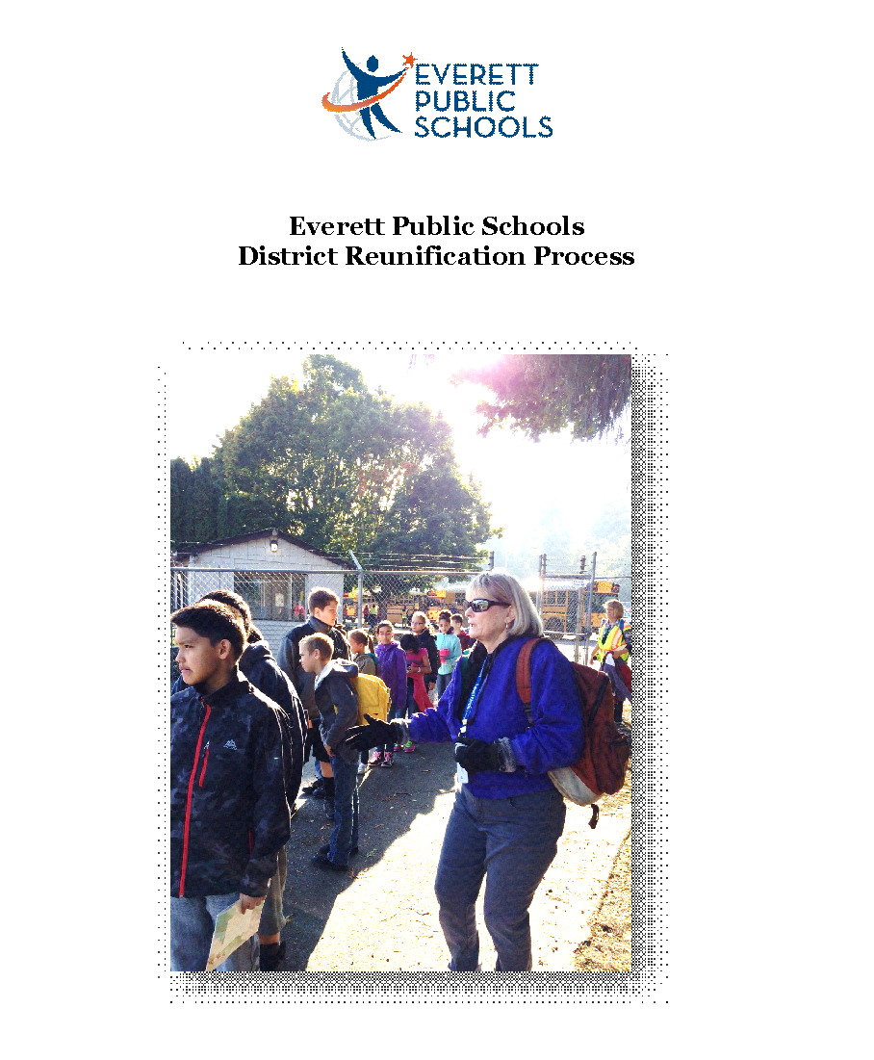

**Introduction and Purpose**

The reunification process is intended to provide guidance and consistency of practice across the district while at the same time recognizing that each situation is unique and may require flexibility and adjustment. Standardization of practices across schools greatly aids in the ability of the district, the school and community responders to reunify students, staff and their families following a significant traumatic event. This process is intended to be used when an event occurs that requires students to be physically returned to their family at Everett Memorial Stadium.

**Reunification Annex**



**Definitions: Daily Release, Controlled Release and Reunification**

What’s the difference between a controlled release and a full reunification effort?

**Daily release** is what happens every day at school; this is the procedure to let the students free. Some walk into the neighborhood. Others are transported by school or contracted buses. Others take public transportation. Some are picked up by parents or guardians.

C**ontrolled release** is a little different. Usually, it occurs at a different time than the daily release. Perhaps its weather-related, closing the school early, a hazmat incident, or chemistry class gone awry, ultimately the release of students is very similar to the daily release. The difference is typically that students are being sent home at an unusual time because of an unusual, but not traumatic event. Parents are notified that the school is closing early and students are being sent home. This type of event **does not call** for the reunification process.

**Reunification** occurs when events at the school or in the neighborhood demand students are physically returned to parents. In the event of criminal activity, injury or death, additional time may be needed for law enforcement interviews or crisis counseling.

**Reunification Activation**

If the district Emergency Operations Center (EOC) is operationalized, the reunification decision will be made by the district reunification director/EOC director.

If the incident level does not necessitate EOC activation, the reunification location and timing is decided by the region assistant/associate superintendent in consultation with the principal or designee, local law enforcement and the district’s reunification team. Everett Memorial Stadium will be the district’s designated reunification site (Appendix A).

The district’s reunification team members include:

* Assistant Superintendent South Region
* Director Athletics
* Director Categorical Programs
* Director Maintenance and Operations
* Director Communications
* Supervisor Transportation
* Everett Police Department Youth Services Sergeant
* Transportation Contractor Representative

The district reunification director will coordinate the process at Everett Memorial Stadium. Once the decision has been made regarding the location and timing, it **must** be adhered to in order to prevent further confusion and chaos.

**The Reunification Process in a Nutshell**

1. Establish a parent check-in location (Appendix A)
2. Deliver the students to the student staging area (Appendix C), beyond the field of vision of parents/guardians. “Greeters” direct parents/guardians to the parent check-in location, and help them understand the process.
3. Parents/guardians complete a reunification information card (Appendix D).
4. Procedure allows parents/guardians to self-sort during check-in, streamlining the process.
5. Runner retrieves student from the student staging area.
6. Controlled lines of sight allow for communication and other issues to be handled with diminished drama or anxiety.

**Reunification Annex**

1. Medical or investigative contingencies are anticipated.

**Reunification Incident Team**

For a reunification, there are some specific roles. The following chart demonstrates the structure of the Reunification Incident Team*.

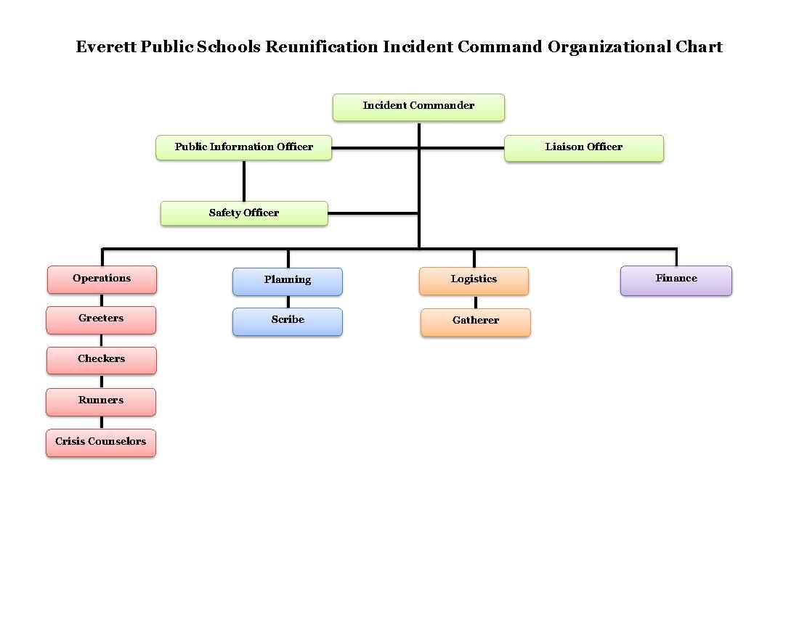



**Reunification Annex**

**Roles and Responsibilities**

|  |  |
| --- | --- |
| **Role** | **Responsibilities** |
| Incident Commander | Defining and coordinating the objective of accountable, easy, reunification of students with parents |
| Public Information Officer | Communicating with parents and press, if appropriate Coordinating use of mass call or text messages and social media |
| Safety Officer | General site observation and safety concern remedy |
| Liaison Officer | Communicating with fire, medical or law enforcement |
| Operations | Establish and manage operational staff |
| Greeters | Help coordinate the parent lines  Tell parents about the process.  Help verify identity of parents without ID |
| Checkers | Verify ID and custody rights of parents/guardians  Direct parents to reunification location |
| Runners | Take bottom of reunification card to student staging area, retrieve student and bring to reunification area |
| Crisis Counselors | Standby unless needed |
| Stage Hands | Initial setup of the check-in area, the signage, student staging area  Stage hands may be assigned to operations as the setup is completed |

*School and district staff will be assigned to various roles as needed.

**Reunification Annex**

**Communications**

Parent/Guardian Communication

Helping parents and guardians understand reunification plans

* The district’s Communications Department will use the communication system to contact families with phone, email and text messages about the situation and reunification plans. They will also post regular updates on the district website and on district social media.
* Share reunification plan reminders with parents each year. This could be:
  + In first day packets
  + As part of a back to school orientation
  + The reunification plan overview is available on the district website at <http://www.everettsd.org/domain/1468> (under the “Parent” tab). You will be able to include this link and call attention to its importance routinely in electronic communications with families and staff
* Help students, parents/guardian and staff know when and how to use social media
  + Share links to the “Social media in emergencies” videos online at <http://docushare.everett.k12.wa.us/docushare/dsweb/View/Collection-8959>

Student Communication during Reunification

* Staff will inform students at various times when it is appropriate for students to text or communicate with their family members.
* Staff will indicate to students the message to share and the importance of adhering to the message so that information is accurately relayed.
* Guiding students in the communications will help alleviate both students and family anxiety about the situation, as well as to assist in communicating more accurate information in regards to event and reunification details.

Second Language Communication

Interpreter agencies will be contacted when a decision has been made to implement reunification. Agency contact information:

* Refugee & Immigrant Services Northwest

425-388-9595 (main line)

* B & L Interpreting Service

425-374-7376 (main line)

Call Center Activation

When the decision has been made to implement reunification, the EOC Call Center will be activated. This will lessen the large number of calls coming into the school and CRC Welcome Desk, and will allow people to call into the EOC for a variety of reasons including:

* They want to know the status of the incident;
* They need assistance;
* They have information; or
* They wish to volunteer to help others.

Calls will also come from staff and volunteers in the field reporting information in addition to calls from the media. The Call Center may be staffed 24 hours a day and often is needed in cleanup and recovery efforts. **The Call Center phone number is 425-385-5555.**

**Reunification Annex**

**School/Staff Responsibilities**

For most emergency functions, successful operations require a coordinated effort from a number of personnel. Staff are responsible for ensuring the care and safety of all students, as well as supervising students during emergency response activities. In the event that the reunification process is implemented, staff should follow evacuation procedures which include:

* Bringing the classroom emergency backpack, emergency cards and student rosters;
* Supervising and reassuring students;
* Administering first aid as necessary or reporting serious injuries;
* Keeping a record of the location of all students at all times; and
* Being alert for latent signs of injury/shock in *all* students.

**Staff Personal Release**

Each staff member in the district should have a personal plan as to how they will be able to return home after a major incident. If the site is a crime scene, staff should to be prepared that they may not be able to readily retrieve their belongings or their automobile and should have contingency arrangements in place. If staff members are able to return to their work site, the district will arrange for transportation to the employees’ work location.

Each staff member will remain with assigned students throughout the duration of the emergency, unless otherwise assigned through a partner system or until every student has been released through the official reunification process. Staff will be released as appropriate and per school/district guidelines. **By law, during a disaster staff become disaster workers.**

Each staff member must check out with their supervisor before leaving the reunification location.

**APPENDICES** **Reunification Annex**

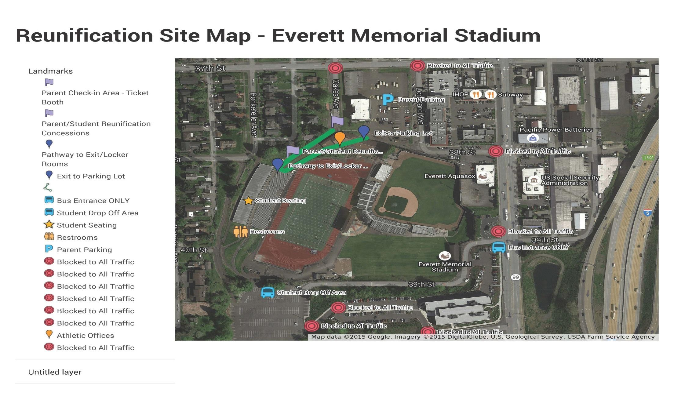

**Reunification Annex**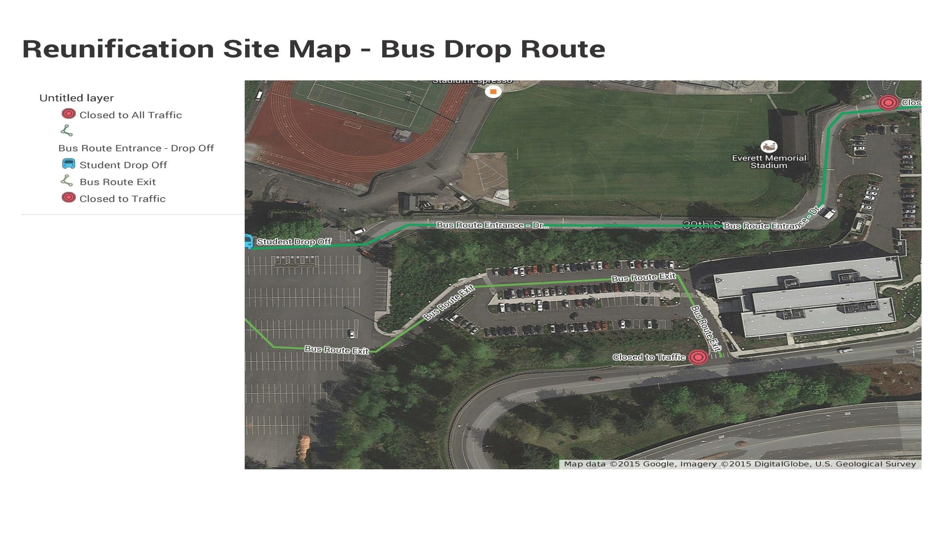

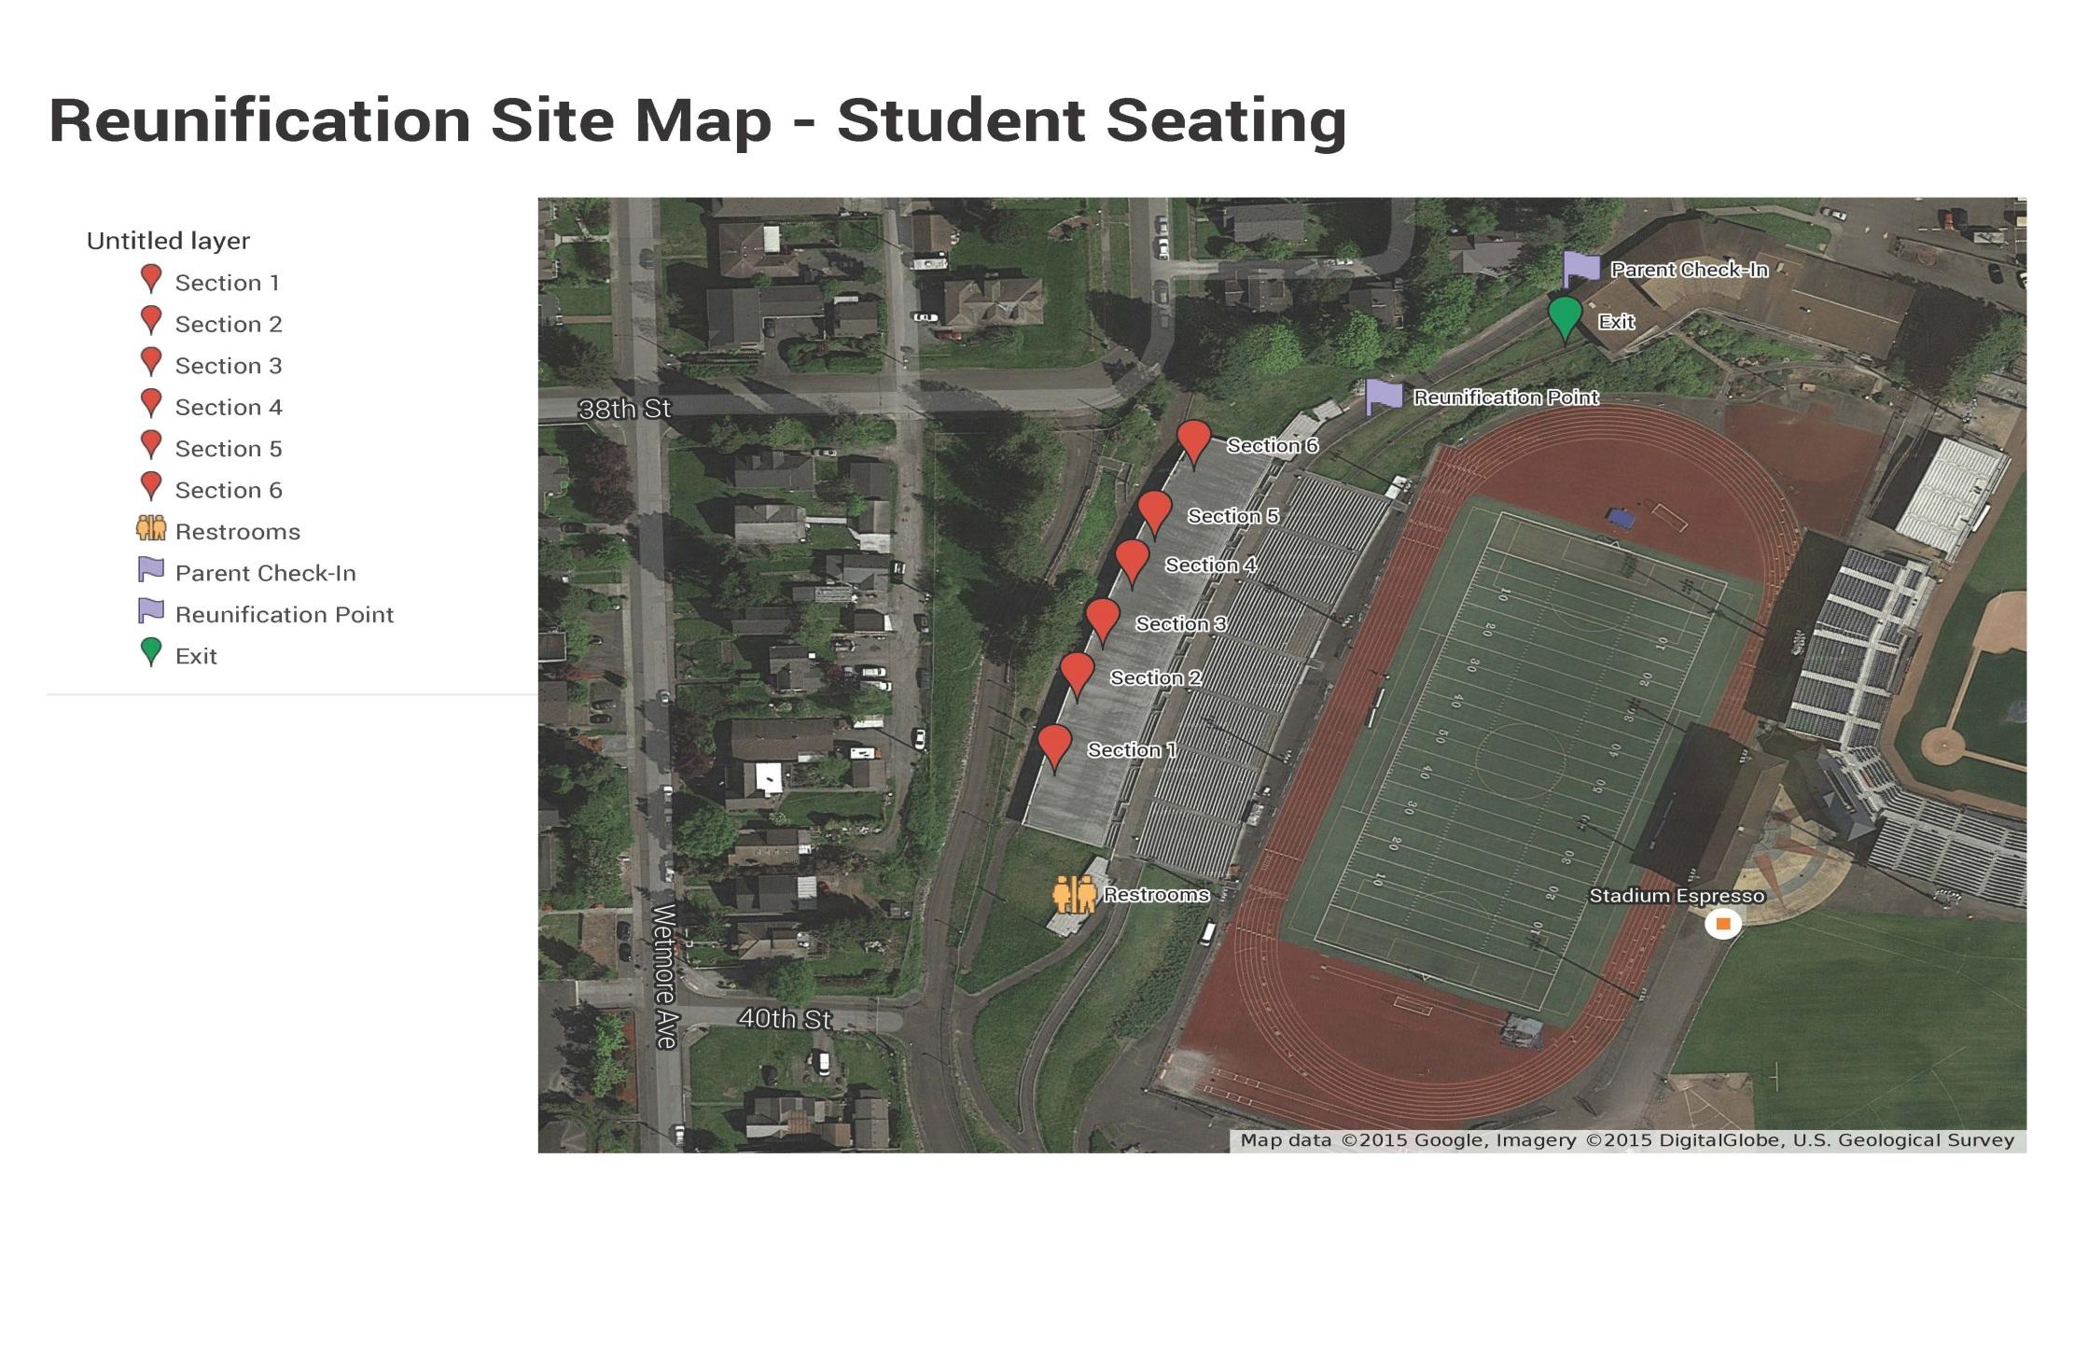

|  |
| --- |
| **Continuity of Operations (COOP) Annex** |

|  |
| --- |
| **Communications and Warning Annex** |

**Lowell 2019.2020 Phone Tree**

|  |  |  |
| --- | --- | --- |
| **Last Name** | **First Name** | **Mobile Number** |
| Armstrong | Bethany | 425-319-1711 |
| Arnold | Robin | 206-498-2731 |
| Autrey-Mtegha | Algia | 251-269-0709 |
| Bernardy | Brittney | 253-249-1300 |
| Britsch | Melissa | 425-350-4928 |
| Bullock | Whitney | 248-820-9370 |
| Bush | Maira | 425-405-2335 |
| Chandler | Hillary | 206-579-6293 |
| Crosby | Mary | 253-678-7852 |
| Detloff | Mary | 425-737-2433 |
| Deubler | Dave | 425-319-8736 |
| Donnelly | Mary | 425-750-6785 |
| Foster | Cindy | 425-344-9836 |
| Fritze | Frances | 425-760-9329 |
| Gay | Shelley | 425-931-5138 |
| Gordon | Michelle | 425-387-4038 |
| Gough | Margo | 425-359-9336 |
| Hagin | Wayne |  |
| Hillstrand | Brenda | 4257915141 |
| Janke | Carla | 425-528-4280 |
| Jarchow | Grace | 4252395774 |
| Johnson | Kerry | 425-870-8980 |
| Juarez | Olivia | 425-293-2096 |
| Karmel | Heba | 206-687-0238 |
| Khan-Calhoun | Doreen | 425-319-3348 |
| Kuntz | Cindy | 425-231-8248 |
| Land | Laura | 206-849-1772 |
| Langille | Krista | 425-626-0943 |
| Lie | Barbara | 360-348-6660 |
| MacIntosh | Alison | 4259223248 |
| Marrow | Erin | 425-215-8952 |
| Martinez | Andria | 425-215-9974 |
| Mason | Ruthie | 339-224-0026 |
| McLauchlin | Macy | 509-844-8106 |
| McPartland | Amber | 425-239-4262 |
| Melnick | Nicole | 425-327-8337 |
| Michalski | Chris | 360-631-2942 |
| Moore | Renee | 425 345 8490 |
| Mullen | Crystal | 4252107350 |
| Neyens | Lindsey | 425-345-7721 |
| O'Connor | Lisa | 425-239-5954 |
| Powers | Daniel | 206-218-2628 |
| Preston | John | 425-773-0897 |
| Rader | Colleen | 425-422-7424 |
| Raymond | Rob | 425-268-1990 |
| Rheaume | Laura | 206-949-2047 |
| Rohling | Lynne | 425 377-5445 |
| Rowland | Mary | 425-350-4555 |
| Saga | Skylar | 425 299 7204 |
| Samuels | Andre | 253-905-4889 |
| Saxena | Pooja | 425-999-9187 |
| Seiber | Amy | 425-238-0851 |
| Shaver | Wendy | 425-343-4391 |
| Sick | Jillian | 425-348-8689 |
| Smith | Cristie | 4253590350 |
| Swalm | Dana | 425 344 3475 |
| Swan | Kelly | 425 275-1249 |
| Thompson | Theresa | 425-231-4301 |
| Vique | Liliana | 425-931-1293 |
| Wartenbee | Stacey | 425-268-6361 |
| Webb | Karah | 425-876-7951 |
| Wilmoth | Emilee | 425-309-3585 |
| Wisniew | Holly | 206-920-7429 |
| Yaniv | Melissa | 425-422-8478 |
| Zehr | Renee | 206-992-3565 |
|  |  |  |

**Communications and Warning Annex**

**Procedure for Reporting Emergencies**

The nature and degree of the emergency will determine whom to call. Give the following information clearly and distinctly on each emergency call to appropriate agencies:

* Your name and position
* Your school site or location and contact phone number
* What is happening or has happened
* The purpose for the call and the degree of urgency
* Where and to whom officers/emergency personnel are to report at the site (be specific)
* A brief report is to be filed with the appropriate regional deputy/assistant superintendent

|  |  |  |
| --- | --- | --- |
| **Key Community Agencies** | **Telephone** |  |
| General Emergency | 911 |  |
| Police/Sheriff/Fire | 911 |  |
| Child Protective Services | 1-866-363-4276 |  |
| Poison Information Center | 1-800-222-1222 |  |
| Snohomish County Dept. of Emergency Management | 425-388-5060 |  |
| Everett Office of Emergency Management | 425-257-8117 |  |
| City of Everett Public Works | 425-257-8832 | 425-257-8821 |
| City of Mill Creek | 425-745-1891 |  |
| Sonitrol Security | 425-258-3655 |  |
| **Key District Contacts** | **Telephone** | **Cell Phone** |
| Superintendent | 425-385-4018 or  425-385-4019 | 425-785-1614 |
| Deputy Superintendent | 425-385-4017 | 425-366-0491 |
| Assistant Superintendent, North Region | 425-385-4020 | 206-854-3372 |
| Assistant Superintendent, South Region | 425-385-4023 | 360-909-4443 |
| Assistant Superintendent, Central Region | 425-385-4021 | 425-308-2448 |
| Associate Superintendent, Curriculum & Assessment | 425-385-4050 | 206-778-4253 |
| Executive Director, Facilities & Operations | 425-385-4190 | 425-367-3631 |
| Executive Director, Finance & Business Services | 425-385-4150 | 425-760-1967 |
| Executive Director, Human Resources | 425-385-4100 | 360-791-9174 |
| Director, Communications | 425-385-4040 | 206-949-5217 |
| Director, Maintenance & Operations | 425-385-5200 | 206-999-1978 |
| Supervisor, Transportation | 425-385-4144 | 360-362-0069 |
| Food Services | 425-385-4380 | 425-422-3003 |
| Student Support Services | 425-385-4033 | 425-299-0364 |
| **Utilities** | **Telephone** |  |
| Snohomish County PUD | 425-783-5050 |  |
| Puget Sound Energy (Natural Gas Service) | 888-225-5773 |  |
| Alderwood Water District | 425-422-0379  425-787-0250 |  |
| Silver Lake Water District | 425-337-3647 |  |

**Communications and Warning Annex**

**Blackboard Connect Instructions**

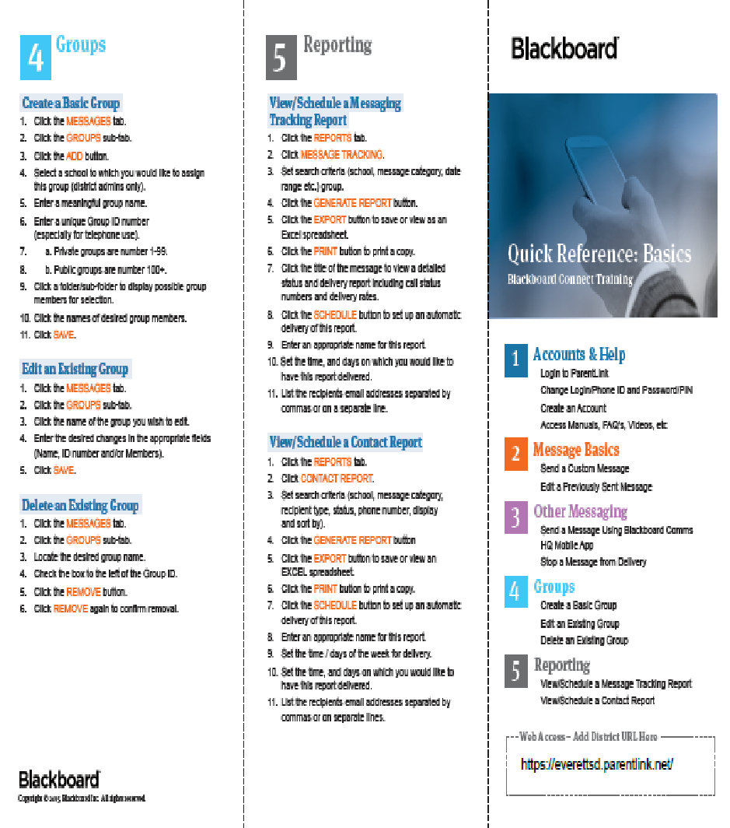

**Communications and Warning Annex**

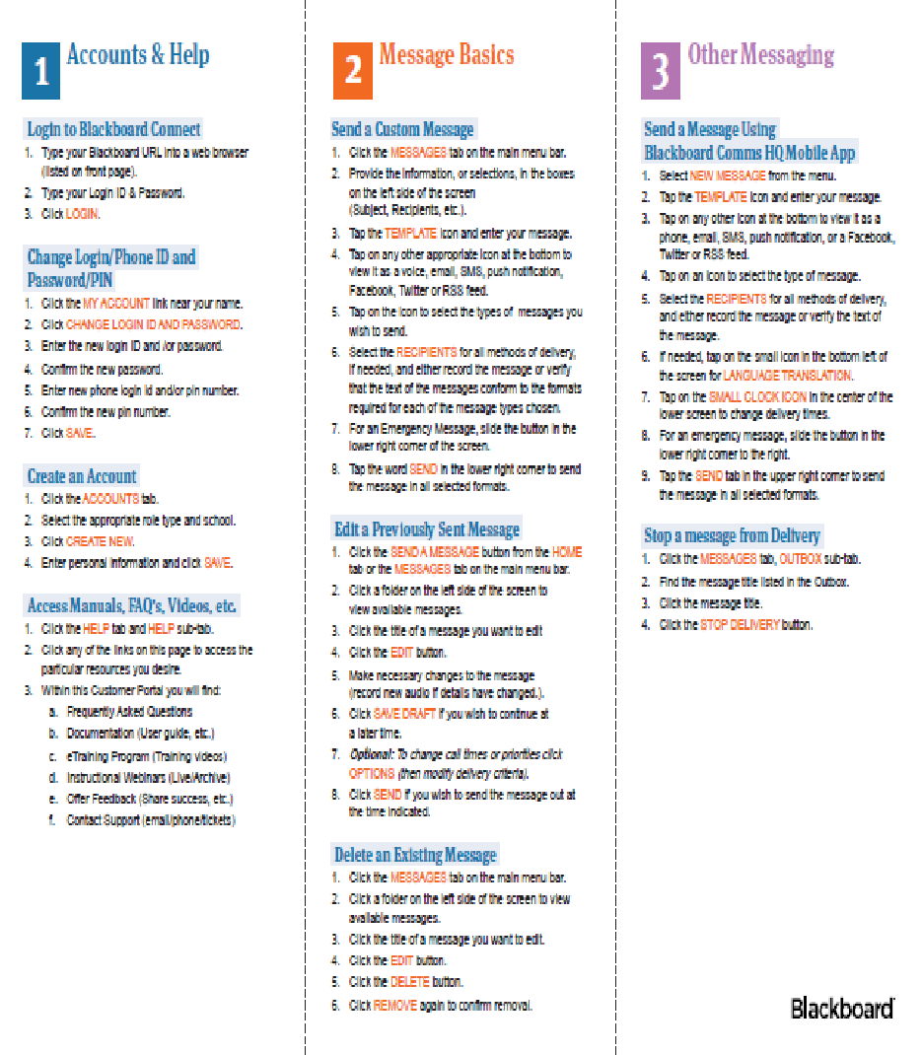

**District**

**Reunification**



|  |
| --- |
| **II. DISTRICT REUNIFICATION** |

**Introduction and Purpose**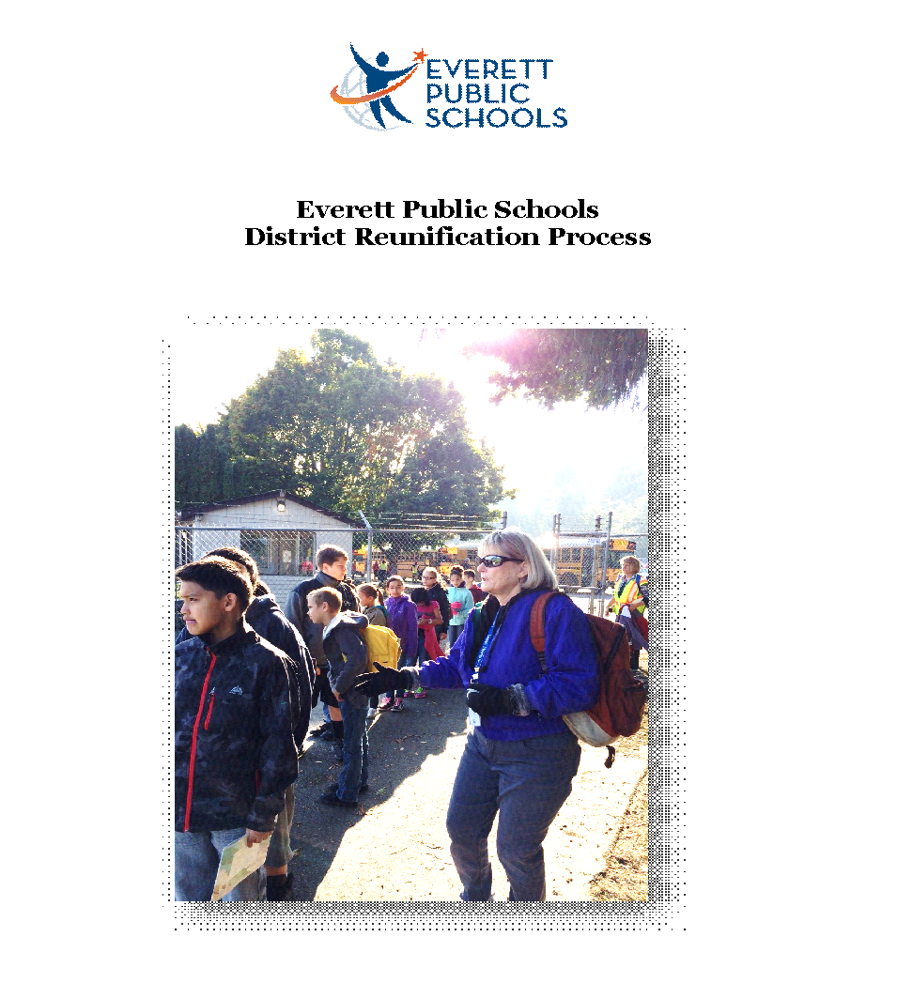

The reunification process is intended to provide guidance and consistency of practice across the district while at the same time recognizing that each situation is unique and may require flexibility and adjustment. Standardization of practices across schools greatly aids in the ability of the district, the school and community responders to reunify students, staff and their families following a significant traumatic event. This process is intended to be used when an event occurs that requires students to be physically returned to their family at Everett Memorial Stadium.

|  |
| --- |
| **Reunification Annex** |

**Definitions: Daily Release, Controlled Release and Reunification**

What’s the difference between a controlled release and a full reunification effort?

**Daily release** is what happens every day at school; this is the procedure to let the students free. Some walk into the neighborhood. Others are transported by school or contracted buses. Others take public transportation. Some are picked up by parents or guardians.

C**ontrolled release** is a little different. Usually, it occurs at a different time than the daily release. Perhaps its weather-related, closing the school early, a hazmat incident, or chemistry class gone awry, ultimately the release of students is very similar to the daily release. The difference is typically that students are being sent home at an unusual time because of an unusual, but not traumatic event. Parents are notified that the school is closing early and students are being sent home. This type of event **does not call** for the reunification process.

**Reunification** occurs when events at the school or in the neighborhood demand students are physically returned to parents. In the event of criminal activity, injury or death, additional time may be needed for law enforcement interviews or crisis counseling.

**Reunification Activation**

If the district Emergency Operations Center (EOC) is operationalized, the reunification decision will be made by the district reunification director/EOC director.

If the incident level does not necessitate EOC activation, the reunification location and timing is decided by the region assistant/associate superintendent in consultation with the principal or designee, local law enforcement and the district’s reunification team. Everett Memorial Stadium will be the district’s designated reunification site (Appendix A).

The district’s reunification team members include:

* Assistant Superintendent South Region
* Director Athletics
* Director Categorical Programs
* Director Maintenance and Operations
* Director Communications
* Supervisor Transportation
* Everett Police Department Youth Services Sergeant
* Transportation Contractor Representative

The district reunification director will coordinate the process at Everett Memorial Stadium. Once the decision has been made regarding the location and timing, it **must** be adhered to in order to prevent further confusion and chaos.

**The Reunification Process in a Nutshell**

1. Establish a parent check-in location (Appendix A)
2. Deliver the students to the student staging area (Appendix C), beyond the field of vision of parents/guardians. “Greeters” direct parents/guardians to the parent check-in location, and help them understand the process.
3. Parents/guardians complete a reunification information card (Appendix D).
4. Procedure allows parents/guardians to self-sort during check-in, streamlining the process.
5. Runner retrieves student from the student staging area.
6. Controlled lines of sight allow for communication and other issues to be handled with diminished drama or anxiety.
7. Medical or investigative contingencies are anticipated.

**Reunification Annex**

**Reunification Incident Team**

For a reunification, there are some specific roles. The following chart demonstrates the structure of the Reunification Incident Team*.





**Reunification Annex**

**Roles and Responsibilities**

|  |  |
| --- | --- |
| **Role** | **Responsibilities** |
| Incident Commander | Defining and coordinating the objective of accountable, easy, reunification of students with parents |
| Public Information Officer | Communicating with parents and press, if appropriate Coordinating use of mass call or text messages and social media |
| Safety Officer | General site observation and safety concern remedy |
| Liaison Officer | Communicating with fire, medical or law enforcement |
| Operations | Establish and manage operational staff |
| Greeters | Help coordinate the parent lines  Tell parents about the process.  Help verify identity of parents without ID |
| Checkers | Verify ID and custody rights of parents/guardians  Direct parents to reunification location |
| Runners | Take bottom of reunification card to student staging area, retrieve student and bring to reunification area |
| Crisis Counselors | Standby unless needed |
| Stage Hands | Initial setup of the check-in area, the signage, student staging area  Stage hands may be assigned to operations as the setup is completed |

*School and district staff will be assigned to various roles as needed.

**Reunification Annex**

**Communications**

Parent/Guardian Communication

Helping parents and guardians understand reunification plans

* The district’s Communications Department will use the communication system to contact families with phone, email and text messages about the situation and reunification plans. They will also post regular updates on the district website and on district social media.
* Share reunification plan reminders with parents each year. This could be:
  + In first day packets
  + As part of a back to school orientation
  + The reunification plan overview is available on the district website at <http://www.everettsd.org/domain/1468> (under the “Parent” tab). You will be able to include this link and call attention to its importance routinely in electronic communications with families and staff
* Help students, parents/guardian and staff know when and how to use social media
  + Share links to the “Social media in emergencies” videos online at <http://docushare.everett.k12.wa.us/docushare/dsweb/View/Collection-8959>

Student Communication during Reunification

* Staff will inform students at various times when it is appropriate for students to text or communicate with their family members.
* Staff will indicate to students the message to share and the importance of adhering to the message so that information is accurately relayed.
* Guiding students in the communications will help alleviate both students and family anxiety about the situation, as well as to assist in communicating more accurate information in regards to event and reunification details.

Second Language Communication

Interpreter agencies will be contacted when a decision has been made to implement reunification. Agency contact information:

* Refugee & Immigrant Services Northwest

425-388-9595 (main line)

* B & L Interpreting Service

425-374-7376 (main line)

Call Center Activation

When the decision has been made to implement reunification, the EOC Call Center will be activated. This will lessen the large number of calls coming into the school and CRC Welcome Desk, and will allow people to call into the EOC for a variety of reasons including:

* They want to know the status of the incident;
* They need assistance;
* They have information; or
* They wish to volunteer to help others.

Calls will also come from staff and volunteers in the field reporting information in addition to calls from the media. The Call Center may be staffed 24 hours a day and often is needed in cleanup and recovery efforts. **The Call Center phone number is 425-385-5555.**

**Reunification Annex**

**School/Staff Responsibilities**

For most emergency functions, successful operations require a coordinated effort from a number of personnel. Staff are responsible for ensuring the care and safety of all students, as well as supervising students during emergency response activities. In the event that the reunification process is implemented, staff should follow evacuation procedures which include:

* Bringing the classroom emergency backpack, emergency cards and student rosters;
* Supervising and reassuring students;
* Administering first aid as necessary or reporting serious injuries;
* Keeping a record of the location of all students at all times; and
* Being alert for latent signs of injury/shock in *all* students.

**Staff Personal Release**

Each staff member in the district should have a personal plan as to how they will be able to return home after a major incident. If the site is a crime scene, staff should to be prepared that they may not be able to readily retrieve their belongings or their automobile and should have contingency arrangements in place. If staff members are able to return to their work site, the district will arrange for transportation to the employees’ work location.

Each staff member will remain with assigned students throughout the duration of the emergency, unless otherwise assigned through a partner system or until every student has been released through the official reunification process. Staff will be released as appropriate and per school/district guidelines. **By law, during a disaster staff become disaster workers.**

Each staff member must check out with their supervisor before leaving the reunification location.

**APPENDICES** **Reunification Annex**



**Reunification Annex**

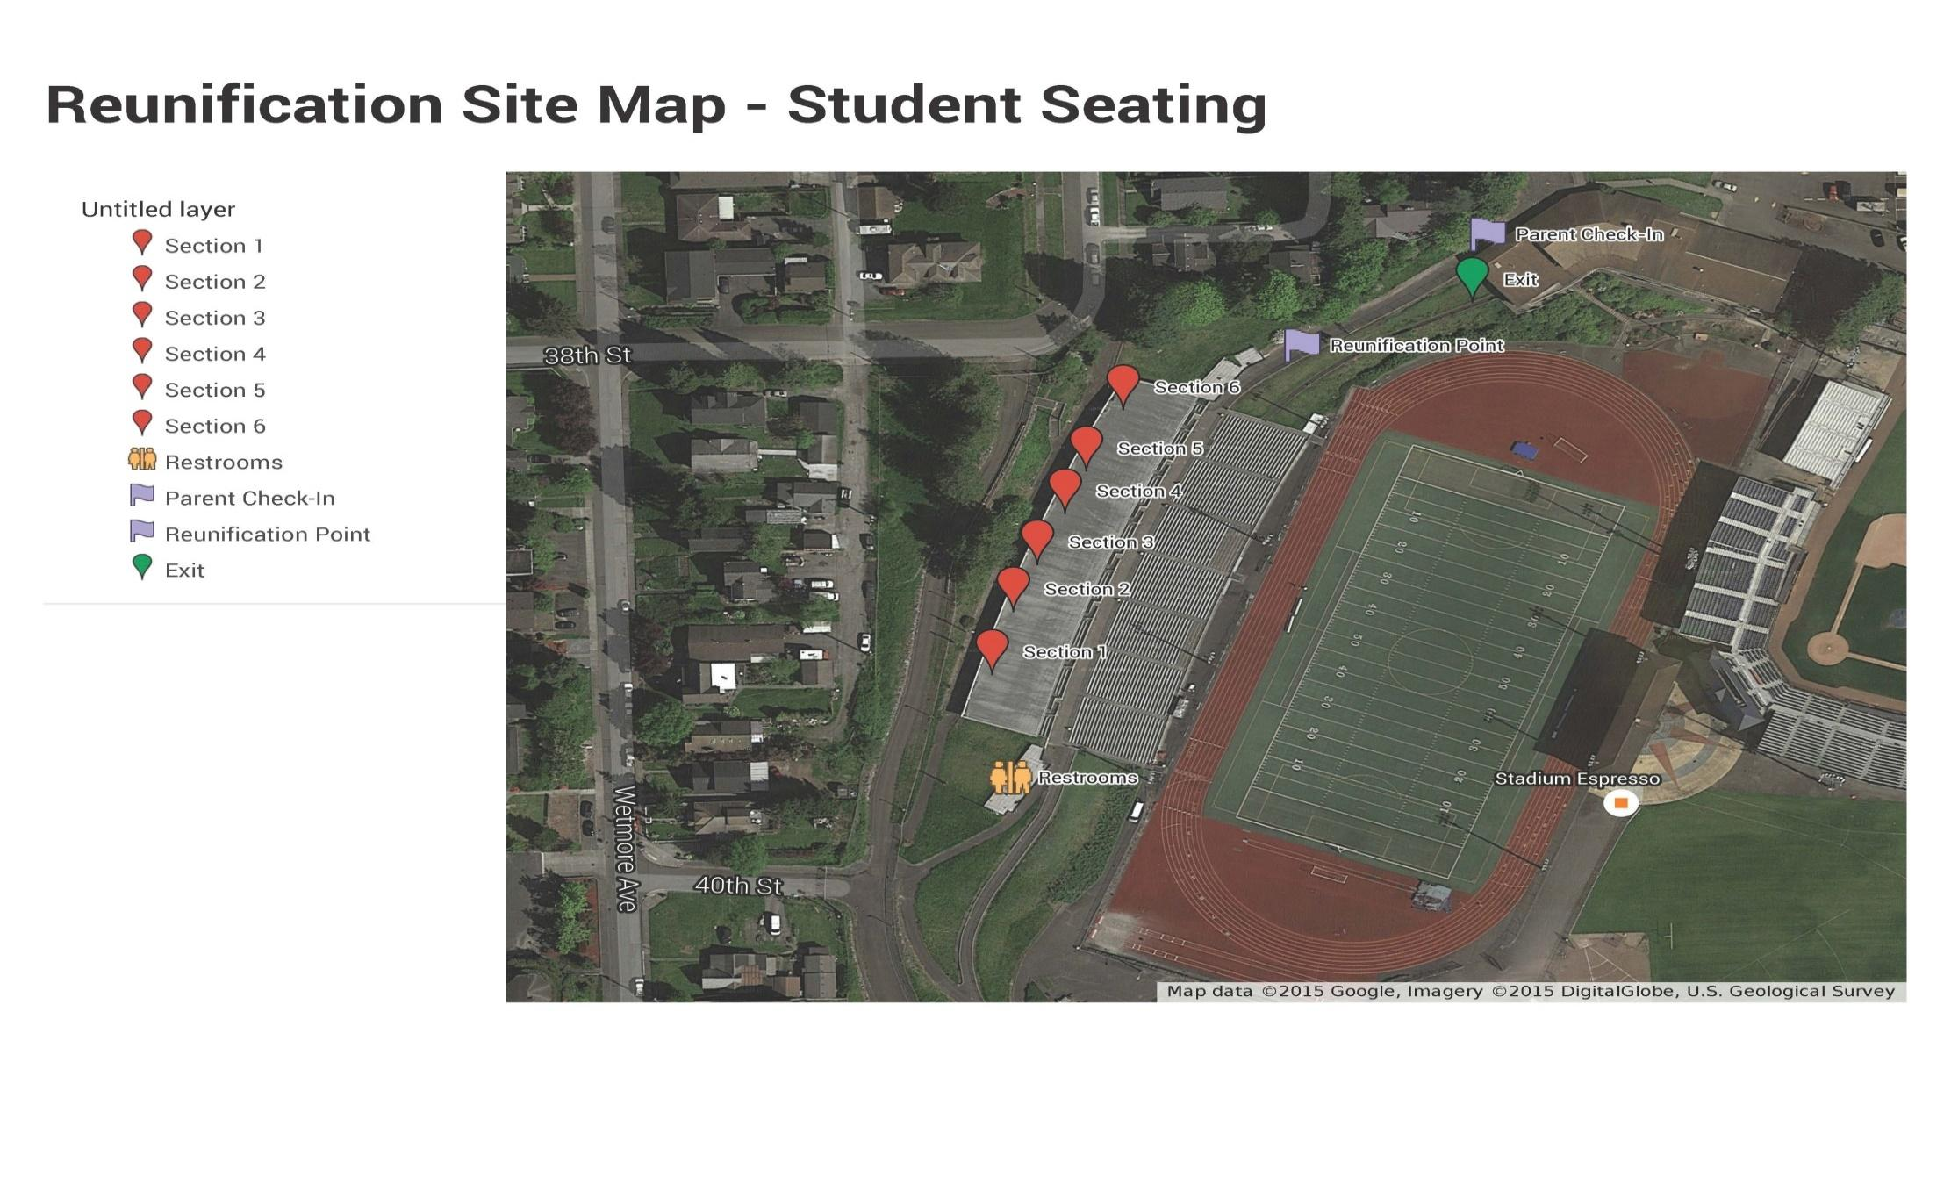

**Incident Command**



|  |
| --- |
| **III. CONCEPT OF OPERATIONS** |

This plan is based upon the concept that the incident management functions that must be performed by the school generally parallel some of their routine day-to-day functions. To the extent possible, the same personnel and material resources used for day-to-day activities will be employed during incidents. Because personnel and equipment resources are limited, some routine functions that do not contribute directly to the incident may be suspended. The personnel, equipment, and supplies that would typically be required for those routine functions will be redirected to accomplish assigned incident management tasks.

**A. National Incident Management System (NIMS)**

NIMS is a set of principles that provides a systematic, proactive approach guiding government agencies at all levels, non-governmental organizations, and the private sector to work seamlessly to prevent, protect against, respond to, recover from, and mitigate the effects of incidents, regardless of cause, size, location, or complexity, in order to reduce the loss of life or property and harm to the environment. This system ensures that those involved in incident response/recovery understand what their roles are and have the tools they need to be effective.

According to Homeland Security Presidential Directive 5 and the U.S. Department of Education, school districts are among local agencies that must adopt NIMS if they receive Federal grant funds. As part of its NIMS implementation, each school participates in the local government’s NIMS preparedness program and believes it is essential to ensure that response/recovery services are delivered to schools in a timely and effective manner.

We recognize that staff and students will be first responders during an incident. Adopting NIMS enables staff and students to respond more effectively to an incident and enhances cooperation, coordination, and communication among school officials, first responders, and emergency managers.

Each school works with local government agencies to remain NIMS compliant. NIMS compliance for school districts includes completing the following:

* Adopt the use of the Incident Command System (ICS). All staff and students who assume roles described in this plan will receive ICS-100 training. ICS-100 is a Web-based course available free from the Federal Emergency Management Agency (FEMA) Emergency Management Institute.
* Complete NIMS awareness course IS-700 NIMS: An Introduction. IS-700 is a Web-based course available free from the Emergency Management Institute. All persons assuming roles described in the basic plan or annexes will take the IS-700 course.
* Participate in local government’s NIMS preparedness program and incorporate the school plan into the community EOP.
* Train and exercise the plan. All staff and students are expected to participate in training and exercising the plan’s procedures and hazard-specific incident plans. The school is charged with ensuring that the training and equipment necessary for an appropriate response/recovery operation are in place.

**B. Implementation of the Incident Command System (ICS)**

In a major emergency or disaster, schools may be damaged or need to be evacuated, people may be injured, and/or other incident management activities may need to be initiated. These activities must be organized and coordinated to ensure efficient incident management. ICS will be used to manage all incidents and major planned events.

The Incident Commander at each school will be delegated the authority to direct all incident activities within the school’s jurisdiction. The Incident Commander will establish an incident command post (ICP) and provide an assessment of the situation to the principal or other officials, identify incident management resources required, and direct the on-scene incident management activities from the ICP. If no Incident Commander is present at the onset of the incident, the most qualified individual will assume command until relieved by a qualified Incident Commander.

**C. Initial Response**

School personnel are usually first on the scene of an incident in a school setting. Staff are expected to take charge and manage the incident until it is resolved, or command is transferred to someone more qualified and/or to an emergency responder agency with legal authority to assume responsibility. Staff will seek guidance and direction from local officials and seek technical assistance from State and Federal agencies and industry where appropriate.

The principal or his/her designee is responsible for activating the school EOP, including common and specialized procedures as well as hazard-specific incident plans. The principal or designee will assign an Incident Commander based on who is most qualified for that type of incident.

**D. Notification Procedures**

In case of an incident, the flow of information shall be from the principal/designee to the district office. Information should include the nature of the incident and the impact, on the facility, students and staff.

In the event the district is in receipt of information, such as a weather warning that may affect a school, the information shall be provided to the principal/designee.

* When an emergency occurs, the principal/administrator will determine with their building teams and the regional deputy/assistant superintendent, the significance of the site emergency, the level of intervention that is needed, and the level of services and resources needed to manage the incident. In many cases school staff may well be able to handle the situation or may need additional assistance.
* The site team may need to draw on the resources from other sites within their regions. Additional staff needed to handle the site emergency may be requested through the regional deputy/assistant superintendent.
* When the emergency is significant, the principal/administrator will inform their regional deputy/assistant superintendent who will inform the superintendent/designee who informs the school board.
* Communications will be notified by the regional deputy/assistant superintendent. When it appears the media will be involved, Communications will be involved in making a determination as to the best method of handling the public communication.

**E. Training and Exercising the Plan**

The school staff understands the importance of training, drills, and exercises in maintaining and planning for an incident. To ensure that staff and community first responders are aware of their duties and responsibilities under the EOP and the most current procedures, the following training, drill, and exercise actions will occur.

1. Training and refresher training sessions shall be conducted annually for staff as appropriate.

2. Information addressed in these sessions will include updates on plans and/or procedures and changes in the duties and responsibilities of plan participants. Input from all employees is encouraged.

3. Per state law, each school will conduct at least one drill per month, including in July and August if students are attending summer school. Drills must practice three functional threat responses: (1) shelter-in-place; (2) lockdown; and (3) evacuation. In addition, a drop, cover, and hold earthquake drill, and at least one drill using the school mapping system (Rapid Responder).

4. Per district requirement, two of the yearly drills must include the Rave application.

To ensure that schools’ practice at least one drill per month, and to allow for response to locally identified threats and hazards, schools may practice basic selected drills more than once. Additional training may include drills, and possibly tabletop and functional exercises. Records of drills (or other training provided) will be maintained as required by state law. Approved parent volunteers and community members may also be incorporated into larger training efforts.

All school staff members are encouraged to develop personal and family emergency plans. Each family should anticipate that a staff member may be required to remain at school following a catastrophic event. Knowing that the family is prepared and can handle the situation will enable school staff to do their jobs more effectively.

**F. Emergencies Occurring During Summer or Other School Breaks**

If a school administrator or other emergency response team member is notified of an emergency during the summer, the response usually will be one of limited school involvement. In that case, the following steps should be taken:

1. Notify the appropriate regional deputy/assistant superintendent. Disseminate information to EOP Team members and request a meeting of all available members.

2. Identify staff/students most likely to be affected by the emergency. Keep the list and recheck it when school reconvenes.

3. Consult with the District Response Team.

4. Notify staff or families of students identified in #2 and recommend community resources for support.

5. Notify general faculty/staff by letter or telephone with appropriate information.

6. Schedule a staff meeting for an update the week before students return to school.

7. Be alert for repercussions among students and staff. When school reconvenes, check core group friends and other at-risk students and staff, and institute appropriate support mechanisms and referral procedures.

|  |
| --- |
| **IV. ORGANIZATION AND ASSIGNMENT OF RESPONSIBILITIES** |

The principal and assistant principals are not able to manage all the aspects associated with an incident without assistance. Other key school personnel will perform tasks that will ensure the safety of students and staff during a crisis or critical incident.

ICS uses a team approach to manage incidents. It is difficult to form a team while a crisis or critical incident is unfolding. Roles should be pre-assigned based on training and qualifications. Each staff member and volunteer must be familiar with his or her role and responsibilities before an incident occurs.

School staff may be required to remain at school to assist in an incident. In the event that the EOP is activated, staff will be assigned to serve within the ICS based on their expertise and training and the needs of the incident.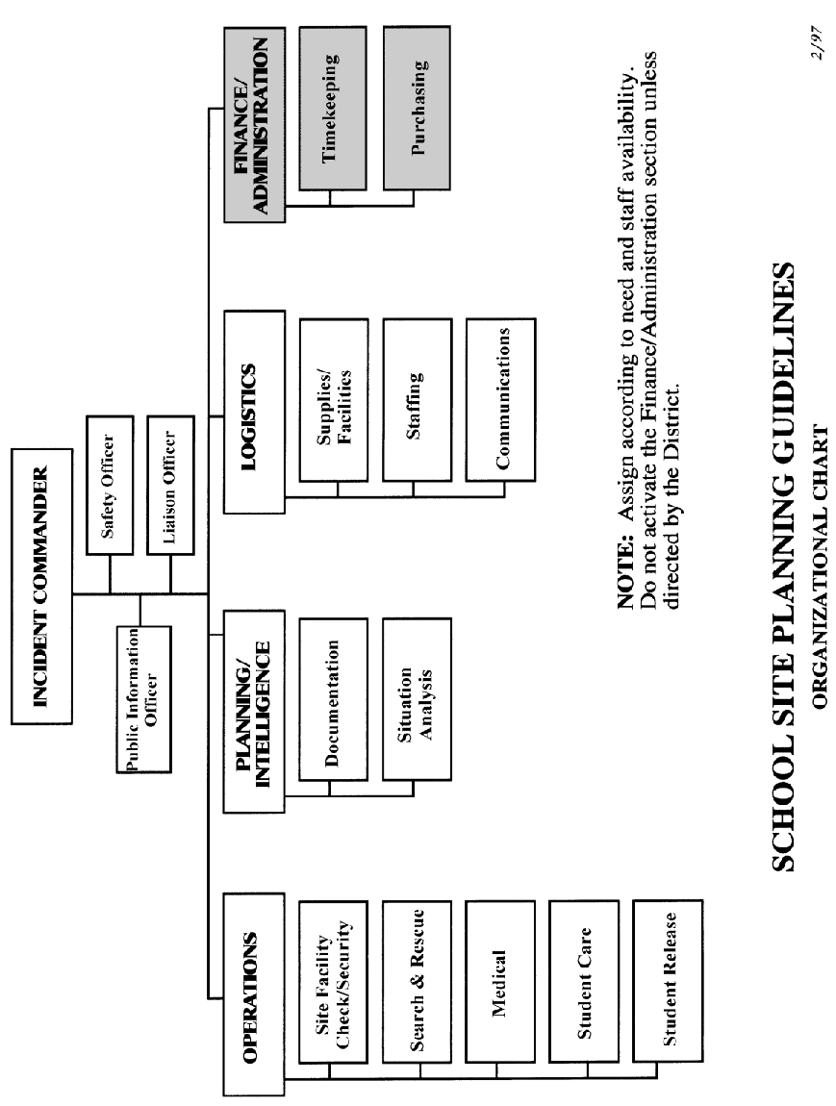

**INCIDENT COMMAND SYSTEM ORGANIZATIONAL CHART**

|  |
| --- |
| **V. DIRECTION, CONTROL, AND COORDINATION** |

**A. School Incident Command System (ICS)**

To provide for the effective direction, control, and coordination of an incident, either single site or multi-incidents, the EOP will be activated including the implementation of ICS. Specific ICS roles and responsibilities can be found in the *Incident Command System Annex*.

**B. Coordination with Policy/Coordination Group**

In complex incidents, a Policy/Coordination Group will be convened at the district emergency operations center. The role of the Policy/Coordination Group is to:

* Support the on-scene Incident Commander.
* Provide policy and strategic guidance.
* Help ensure that adequate resources are available.
* Identify and resolve issues common to all organizations.
* Keep elected officials and other executives informed of the situation and decisions.
* Provide factual information, both internally and externally through the Joint Information Center.

The School Principal and Incident Commander will keep the Policy/Coordination Group informed.

**C. District Emergency Operations Plan (EOP)**

Everett Public Schools maintains a district EOP to address hazards and incidents. The EOP has been developed to fit into the larger district EOP in the case of a large-scale incident.

**D. Source and Use of Resources**

The school will use its own resources and equipment to respond to incidents until incident response personnel arrive. If additional resources are required, the following options exist:

1) Request assistance from volunteer groups active in disasters.

2) Request assistance from industry or individuals who have resources needed to assist with the emergency situation.

|  |
| --- |
| **VI. ADMINISTRATION, FINANCE, AND LOGISTICS** |

**A. Agreements and Contracts**

Should school/district resources prove to be inadequate during an emergency; requests will be made for assistance from local emergency services, other agencies and industry in accordance with existing mutual-aid agreements and contracts and those agreements and contracts concluded during the emergency. Such assistance may include equipment, supplies or personnel. All agreements will be entered into by authorized officials and should be in writing whenever possible. The superintendent will designate school district officials authorized to request assistance pursuant to those documents.

**B. Reports**

1. Initial Emergency Report

This short report should be prepared and transmitted by the Incident Command Post.

2. Situation Report

A daily situation report should be prepared and distributed by the Incident Command Post during major emergencies or disasters.

**C. Records**

1. Recordkeeping for Emergency Operations

The school is responsible for establishing administrative controls necessary to manage the expenditure of funds and to provide reasonable accountability and justification for expenditures made to support incident management operations. These administrative controls will be done in accordance with the established local fiscal policies and standard cost accounting procedures.

2. Activity Logs

The ICS Section Chiefs and the district office will maintain accurate logs recording key incident management activities, including:

* Activation or deactivation of incident facilities.
* Significant changes in the incident situation.
* Major commitments of resources or requests for additional resources from external sources.
* Issuance of protective action recommendations to the staff and students.
* Evacuations.
* Casualties.
* Containment or termination of the incident.

3. Incident Costs

Records shall be maintained summarizing the use of personnel, equipment and supplies during the response to day-to-day incidents to obtain an estimate of annual emergency response costs that can be used in preparing future district/school budgets.

4. Emergency or Disaster Costs

For major emergencies or disasters, detailed records of the emergency response shall be maintained of costs for emergency operations to include:

1) Personnel costs, especially overtime costs.

2) Equipment operations costs.

3) Costs for leased or rented equipment.

4) Costs for contract services to support emergency operations.

5) Costs of specialized supplies expended for emergency operations.

These records may be used to recover costs from the responsible party or insurers or as a basis for requesting financial assistance for certain allowable response and recovery costs from the state and/or federal government.

**D. Preservation of Records**

In order to continue normal school operations following an incident, vital records must be protected. These include legal documents and student files, as well as property and tax records. The principal causes of damage to records are fire and water; therefore, essential records should be protected accordingly. Details are outlined in the *Continuity of Operations (COOP) Annex*.

If records are damaged during an emergency situation, Everett Public Schools will seek professional assistance to preserve and restore them.

**E. Consumer Protection**

Consumer or community complaints often occur in the aftermath of a disaster. Such complaints will be referred to the Everett Public Schools’ superintendent/designee who will pass such complaints to the appropriate department(s) for resolution.

**F. Post-Incident and Exercise Review**

The superintendent/designee/district emergency management coordinator/emergency operations planning team and emergency response teams are responsible for organizing and conducting a critique following the conclusion of a significant emergency event/incident or exercise. The critique will entail both written and verbal input from all appropriate participants. Where deficiencies are identified, Everett Public Schools personnel will be assigned responsibility for correcting the deficiency.

|  |
| --- |
| **VII. PLAN DEVELOPMENT, MAINTENANCE, AND DISTRIBUTION** |

The Safety Team IS responsible for the overall maintenance and revision of the EOP. Staff are expected to work closely together to make recommendations for revising and enhancing the plan.

The principal or designee is responsible for approving and promulgating this plan. Community fire, law enforcement, and emergency managers’ suggestions may also be requested.

**A. Approval and Dissemination of the Plan**

The principal or designee will approve and disseminate the plan and its annexes following these steps:

* Review and validate the plan
* Present the plan (for comment or suggestion)
* Obtain plan approval
* Distribute the plan

**B. Plan Review and Updates**

The basic plan and its annexes will be reviewed annually by the Safety Team and any others deemed appropriate by school administration. The principal or designee will establish a schedule for annual review of planning documents.

The EOP will be updated based upon deficiencies identified during incident management activities and exercises and when changes in threat hazards, resources and capabilities, or school structure occur.

|  |
| --- |
| **VIII. AUTHORITIES AND REFERENCES** |

The following regulations are the State authorizations and mandates upon which this Emergency Operations Plan is based. These authorities and references provide a legal basis for incident management operations and activities.

**Authority**

**A. Federal**

1. Homeland Security Presidential Directive 8 “*National Preparedness*” (HSPD-8)

**B. State**

1. [RCW 28A.320.125](http://apps.leg.wa.gov/RCW/default.aspx?cite=28A.320.125) – Safe school plans—Requirements—Duties of school districts, schools, and educational service districts—Reports—Drills—Rules.

2. [WAC 118-30-060](http://apps.leg.wa.gov/wac/default.aspx?cite=118-30-060) – Emergency Plan.

**References**

* Office for Domestic Preparedness *Emergency Response Planning for WMD/Terrorism Incidents Technical Assistance Program*
* FEMA Independent Study Program: IS 362.A – *Multi-Hazard Emergency Planning for Schools* Washington State Emergency Management Division in Partnership *Comprehensive All Hazard Planning Guide and Model School Plan for Washington State Schools*
* U.S. Department of Education *Guide for Developing High-Quality School Emergency Operations Plans*
* Jane’s Safe Schools Planning Guide for All Hazards

|  |
| --- |
| **Incident Command System Annex** |

**Incident Command for SCHOOL NAME School**













**Incident Command System Annex**

**ICS Job Responsibilities**

**Incident Commander – School Command Post**

|  |  |
| --- | --- |
| Responsibilities: | **The Incident Commander is solely responsible for emergency/disaster operations and shall remain at the Command Post to observe and direct all operations.**  Ensure the safety of students, staff, and others on campus. Lead by example: your behavior sets tone for staff and students. |
| Start-up actions: | ▪ Obtain your personal safety equipment (i.e., hard hat, vest, clipboard with job description sheet).  ▪ Assess the type and scope of emergency.  ▪ Determine the threat to human life and structures.  ▪ Implement the emergency plan and hazard-specific procedures.  ▪ Develop and communicate an incident action plan with objectives and a timeframe to meet those objectives.  ▪ Activate functions and assign positions as needed.  ▪ Fill in the Incident Assignments form.  ▪ Appoint a backup or alternate Incident Commander (as described in the emergency plan). |
| Ongoing operational duties: | ▪ Continue to monitor and assess the total school situation:   * View the site map periodically for search and rescue progress and damage assessment information. * Check with chiefs for periodic updates. * Reassign personnel as needed.   ▪ Report to the regional deputy/assistant superintendent on the status of students, staff, and facility, as needed (Site Status Report).  ▪ Develop and communicate revised incident action plans as needed.  ▪ Begin student release when appropriate.  NOTE: No student should be released until student accounting is complete. Never send students home before the end of the regular school day unless directed by the principal/superintendent, except at the request of parent/guardian.  ▪ Authorize the release of information.  ▪ Utilize your backup; plan and take regular breaks (5-10 minutes per hour). During break periods, relocate away from the Command Post.  ▪ Plan regular breaks for all staff and volunteers. Take care of your caregivers!  ▪ Release teachers as appropriate and per school guidelines. (By law, during a disaster, teachers become disaster workers.)  ▪ Remain on and in charge of your campus until redirected or released by the superintendent. |

**Incident Command System Annex**

**Incident Commander – School Command Post** (Continued)

|  |  |
| --- | --- |
| **Closing down:** | ▪ Authorize deactivation of sections when they are no longer required.  ▪ At the direction of the principal/superintendent, deactivate the entire emergency response. If the fire department or other outside agency calls an “all clear,” contact the district before taking any further action.  ▪ Ensure that any open actions not yet completed will be taken care of after deactivation.  ▪ Ensure the return of all equipment and reusable supplies to Logistics.  ▪ Close out all logs. Ensure that all logs, reports, and other relevant documents are completed and provided to the Documentation Unit.  ▪ Announce the termination of the emergency and proceed with recovery operations if necessary. |
| **command post equipment/ supplies:** | ▪ Campus map  ▪ LED Flashlight  ▪ Master keys  ▪ Staff and student rosters  ▪ Disaster response forms  ▪ Emergency plan  ▪ Duplicate rosters (two sets)  ▪ Tables and chairs (if Command Post is outdoors)  ▪ Vests (if available)  ▪ Job description clipboards  ▪ Command Post tray (pens, etc.)  ▪ School district radio  ▪ Campus two-way radios  ▪ AM/FM/ NOAA Weather Alert Radio (batteries)  ▪ Bullhorn |

**Safety Officer**

|  |  |
| --- | --- |
| **Responsibilities:** | The Safety Officer ensures that all activities are conducted in as safe a manner as possible under the existing circumstances. |
| **Start-up actions:** | ▪ Check in with the Incident Commander for a situation briefing.  ▪ Obtain necessary equipment and supplies from Logistics.  ▪ Put on a position identifier, such as a vest, if available.  ▪ Open and maintain a position log. Maintain all required records and documentation to support the history of the emergency or disaster. Document:   * Messages received. * Action taken. * Decision justification and documentation. * Requests filled. |

**Incident Command System Annex**

**Safety Officer** (continued)

|  |  |
| --- | --- |
| **Operational Duties:** | ▪ Monitor drills, exercises, and emergency response activities for safety.  ▪ Identify and mitigate safety hazards and situations.  ▪ Stop or modify all unsafe operations.  ▪ Ensure that responders use appropriate safety equipment.  ▪ Think ahead, anticipate situations and problems before they occur.  ▪ Anticipate situation changes, such as cascading events, in all planning.  ▪ Keep the Incident Commander advised of your status and activity and on any problem areas that now need or will require solutions. |
| **Closing Down:** | ▪ When authorized by the Incident Commander, deactivate the unit and close out all logs. Provide logs and other relevant documents to the Documentation Unit.  ▪ Return equipment and reusable supplies to Logistics. |
| **Equipment/ Supplies:** | ▪ Vest or position identifier, if available  ▪ Hard hat, if available  ▪ LED Flashlight  ▪ Clipboard, paper, pens  ▪ Two-way radio, if available  ▪ NOAA Weather Radio |

**Public Information Officer (PIO)**

|  |  |
| --- | --- |
| **Personnel:** | Available staff with assistance from available volunteers |
| **policy:** | The public has the right and need to know important information related to an emergency/disaster at the school site ***as soon as it is available***.  The PIO acts as the official spokesperson for the school site in an emergency situation.  News media can play a key role in assisting the school in getting emergency/disaster-related information to the public (parents).  Information released must be consistent, accurate, and timely. |
| **Start-up actions:** | ▪ Determine a possible “news center” site as a media reception area (located away from the Command Post and students). Get approval from the Incident Commander.  ▪ Identify yourself as the PIO (by vest, visor, sign, etc.)  ▪ Consult with the district PIO to coordinate information release.  ▪ Assess the situation and obtain a statement from the Incident Commander. Tape-record the statement if possible.  ▪ Advise arriving media that the site is preparing a press release and the approximate time of its issue.  ▪ Open and maintain a position log of your actions and all communications. If possible, tape media briefings. Keep all documentation to support the history of the event. |

**Incident Command System Annex**

**Public Information Officer (PIO)** (Continued)

|  |  |
| --- | --- |
| **Operational Duties:** | ▪ Keep up to date on the situation.  ▪ Statements must be approved by the Incident Commander and should reflect:   * Reassurance (EGBOK— “Everything’s going to be OK.”) * Incident or disaster cause and time of origin. * Size and scope of the incident. * Current situation—condition of school site, evacuation progress, care being given, injuries, student release location, etc. Do not release any names. * Resources in use. * Best routes to the school, if known and if appropriate. * Any information the school wishes to be released to the public.   ▪ **Read** statements if possible.  ▪ When answering questions, be complete and truthful, always considering confidentiality and emotional impact. Avoid speculation, bluffing, lying, talking “off the record,” arguing, etc. Avoid using the phrase “no comment.”  ▪ Remind school staff and volunteers to refer *all* questions from the media or waiting parents to the PIO.  ▪ Update information periodically with the Incident Commander.  ▪ Ensure that announcements and other information are translated into other languages as needed.  ▪ Monitor news broadcasts about the incident. Correct any misinformation heard. |
| **Closing Down:** | ▪ At the Incident Commander’s direction, release PIO staff when they are no longer needed. Direct staff members to sign out through Timekeeping.  ▪ Return equipment and reusable supplies to Logistics.  ▪ Close out all logs. Provide logs and other relevant documents to the Documentation Unit. |
| **Equipment/ Supplies:** | ▪ Public information kit consists of:   * ID vest * Battery-operated AM/FM radio * LED Flashlight * NOAA Weather Radio * Paper/pencils/marking pens * Scotch tape/masking tape * Scissors * School site map(s) and area maps * 8-l/2 x 11 handouts * Laminated poster board size for display   ▪ Forms:   * Disaster Public Information Release Work Sheet * Sample Public Information Release * School Profile or School Accountability Report Card (SARC) |

**Incident Command System Annex**

**Liaison Officer**

|  |  |
| --- | --- |
| **Responsibilities:** | The Liaison Officer serves as the point of contact for agency representatives from assisting organizations and agencies outside the school and assists in coordinating the efforts of these outside agencies by ensuring the proper flow of information. |
| **Start-up actions:** | ▪ Check in with the Incident Commander for a situation briefing.  ▪ Determine your personal operating location and set it up as necessary.  ▪ Obtain the necessary equipment and supplies from Logistics.  ▪ Put on a position identifier, such as a vest, if available.  ▪ Open and maintain a position log. Maintain all required records and documentation to support the history of the emergency or disaster. |
| **Operational Duties:** | ▪ Brief agency representatives on the current situation, priorities, and incident action plan.  ▪ Ensure coordination of efforts by keeping the Incident Commander informed of agencies’ action plans.  ▪ Provide periodic update briefings to agency representatives as necessary. |
| **Closing Down:** | ▪ At the Incident Commander’s direction, deactivate the Liaison Officer position and release staff no longer needed. Direct staff members to sign out through Timekeeping.  ▪ Return equipment and reusable supplies to Logistics.  ▪ Close out all logs. Provide logs and other relevant documents to the Documentation Unit. |
| **Equipment/ Supplies:** | ▪ Vest or position identifier, if available  ▪ Two-way radio, if available  ▪ LED Flashlight  ▪ Clipboard, paper, pens |

**Operations Section Chief**

|  |  |
| --- | --- |
| **Responsibilities:** | The Operations Chief manages the direct response to the disaster, which can include:  ▪ Site Facility Check / Security  ▪ Search and Rescue  ▪ Medical  ▪ Student Care and Student Release |
| **Start-up actions:** | ▪ Check in with the Incident Commander for a situation briefing.  ▪ Obtain necessary equipment and supplies from Logistics.  ▪ Put on a position identifier, such as a vest, if available. |

**Incident Command System Annex**

**Operations Section Chief** (continued)

|  |  |
| --- | --- |
| **Operational Duties:** | ▪ Assume the duties of all operations positions until staff are available.  ▪ As staff members are assigned, brief them on the situation, and supervise their activities, using the position checklists.  ▪ If additional supplies or staff is needed for the Operations Section, notify the Incident Commander. When additional staff arrives, brief them on the situation, and assign them as needed.  ▪ Deploy the search and rescue team if needed.  ▪ As information is received from operations staff, pass it on to Planning Chief to be recorded for “situation analysis” and / or the Incident Commander.  ▪ Ensure that operations staff is following standard procedures, using appropriate safety gear, and documenting their activities.  ▪ Schedule breaks and reassign staff within the section as needed. |
| **Closing Down:** | ▪ At the Incident Commander’s direction, release Operations staff no longer needed. Direct staff members to sign out through Timekeeping.  ▪ Return equipment and reusable supplies to Logistics.  ▪ When authorized by the Incident Commander, deactivate the section and close out all logs. Provide logs and other relevant documents to the Documentation Unit. |
| **Equipment/ Supplies:** | ▪ Vest or position identifier, if available  ▪ Search & Rescue equipment  ▪ Two-way radio / NOAA Weather Radio  ▪ LED Flashlight  ▪ Job description clipboard, paper, pens  ▪ Maps: Search and rescue maps & large campus map |

**Site Facility Check/Security**

|  |  |
| --- | --- |
| **personnel:** | Staff as assigned. Work in pairs |
| **Responsibilities:** | Take no action that will endanger yourself. |
| **Start-up actions:** | ▪ Wear hard hat and orange identification vest, if available.  ▪ Take appropriate tools, job description clipboard, and radio.  ▪ Put batteries in flashlight if necessary. |

**Incident Command System Annex**

**Site Facility Check/Security** (continued)

|  |  |
| --- | --- |
| **Operational Duties:** | As you complete the following tasks, observe the campus and report any damage by radio to the Command Post.  **Remember**: If you are not acknowledged, you have not been heard. Repeat your transmission, being aware of other simultaneous transmissions.  ▪ Lock gates and major external doors.  ▪ Locate, control and extinguish small fires as necessary.  ▪ Check gas meter and, if gas is leaking, shut down the gas supply.  ▪ Shut down electricity only if building has clear structural damage or advised to do so by Command Post.  ▪ Post yellow caution tape around damaged or hazardous areas.  ▪ Verify that the campus is “locked down.”  ▪ Advise the Command Post of all actions taken for proper logging.  ▪ Check entire campus for safety hazards and damage.  ▪ No damage should be repaired before full documentation, such as photographs and video evidence, is complete unless the repairs are essential to immediate life-safety.  ▪ Route fire, rescue, and police, as appropriate.  ▪ Direct all requests for information to the PIO |
| **Closing Down:** | ▪ Return equipment and reusable supplies to Logistics.  ▪ When authorized by the Incident Commander, close out all logs. Provide logs and other relevant documents to the Documentation Unit. |
| **Equipment/ Supplies:** | ▪ Vest, hard hat, work gloves, and whistle.  ▪ LED Flashlight  ▪ NOAA Weather Radio  ▪ Campus two-way radio, master keys, and clipboard with job description.  ▪ Bucket or duffel bag with goggles, flashlight, dust masks, yellow caution tape, and shutoff tools—for gas and water (crescent wrench) |

**Search and Rescue Team**

|  |  |
| --- | --- |
| **Safety rules:** | **Use the buddy system. Assign a minimum of 2 persons to each team.**  Take no action that might endanger you. Do not work beyond your expertise. Use appropriate safety gear. Size up the situation first.  **Follow all operational and safety procedures.** |
| **Start-up actions:** | ▪ Obtain all necessary equipment from Emergency Storage Container.  ▪ Obtain a briefing from Operations Chief of situations requiring response.  ▪ Assign teams based on available manpower, minimum 2 persons per team. |

**Incident Command System Annex**

**Search and Rescue Team** (continued)

|  |  |
| --- | --- |
| **Operational Duties:** | ▪ Perform a visual and radio check of the outfitted team leaving the Command Post. Teams must wear sturdy shoes and safety equipment.  ▪ Record names and assignments before deploying teams.  ▪ Dispatch teams to known hazards or situations first, then to search the campus using specific planned routes. Send a specific map assignment with each team.  ▪ Remain at the Command Post in radio contact with S&R Teams.  ▪ Record all teams’ progress and reports on the site map, keeping others at the Command Post informed of problems. When a room is reported clear, mark a “C” on the map.  ▪ If injured students are located, consult the Operations Section Chief for response. Utilize Transport teams or send a First Aid Team.  ▪ Record the exact location of damage and a triage tally (I=immediate, D=delayed, DEAD=dead) on the map.  ▪ Keep radio communication brief and simple. No codes.   * **Remember:** if you are not acknowledged, you have not been heard. Repeat your transmission, being aware of other simultaneous transmissions. |
| **Closing Down:** | ▪ Record the return of each S&R team. Direct them to return equipment and report to Logistics for additional assignment.  ▪ Provide maps and logs to the Documentation Unit. |
| **Equipment/ Supplies:** | ▪ Vest, hard hat, work and latex gloves, and whistle with master keys on lanyard. One team member should wear a first aid backpack.  ▪ LED Flashlight  ▪ NOAA Weather Radio  ▪ Campus two-way radio and clipboard with job description and map indicating the search plan.  ▪ Bucket or duffel bag containing goggles, flashlight, dust masks, pry bar, grease pencil, pencils, duct tape, and masking tape. |

**Medical Team Leader**

|  |  |
| --- | --- |
| **Responsibilities:** | The Medical Team Leader is responsible for providing emergency medical response, first aid, and counseling. He or she informs the Operations Chief or Incident Commander when the situation requires health or medical services that staff cannot provide. |

**Incident Command System Annex**

**Medical Team Leader** (continued)

|  |  |
| --- | --- |
| **Operational Duties/Start-up actions:** | ▪ Establish scope of disaster with the Incident Commander and determine probability of outside emergency medical support and transport needs.  ▪ Make personnel assignments. If possible, assign a minimum of two people to triage, two to immediate treatment, two to delayed treatment, and two to psychological treatment.  ▪ Set up a first aid area in a safe place (upwind from the emergency area if the emergency involves smoke or hazardous materials), away from students and parents, with access to emergency vehicles. Obtain equipment and supplies from the storage area.  ▪ Assess available inventory of supplies and equipment.  ▪ Review safety procedures and assignments with personnel.  ▪ Establish a point of entry (“triage”) into the treatment area.  ▪ Establish “immediate” and “delayed” treatment areas.  ▪ Set up a separate psychological first aid area if staff levels are sufficient.  ▪ Oversee the assessment, care, and treatment of patients.  ▪ Ensure caregiver and rescuer safety: Ensure that they use latex gloves for protection from body fluids and new gloves for each new patient.  ▪ Make sure that accurate records are kept.  ▪ Provide personnel to respond to injuries in remote locations or request a Transport Team from Logistics.  ▪ If needed, request additional personnel from Logistics.  ▪ Brief newly assigned personnel.  ▪ Report deaths immediately to the Operations Section Chief.  ▪ Keep the Operations Section Chief informed of the overall status.  ▪ Set up a morgue, if necessary, in a cool, isolated, secure area; follow the guidelines established in the plan.  ▪ Stay alert for communicable diseases and isolate appropriately.  ▪ Consult with the Student Care Director regarding health care, medications, and meals for students with known medical conditions (e.g., diabetes, asthma, etc.). |
| **Closing Down:** | ▪ At the Incident Commander’s direction, release medical staff no longer needed. Direct staff members to sign out through timekeeping.  ▪ Return equipment and reusable supplies to Logistics.  ▪ When authorized by the Incident Commander, deactivate the section and close out all logs. Provide the logs and other relevant documents to the Documentation Unit. |

**Incident Command System Annex**

**Medical Team Leader** (continued)

|  |  |
| --- | --- |
| **Equipment/ Supplies:** | ▪ First aid supplies. (See the list on the following page.)  ▪ LED Flashlight & NOAA Weather Radio  ▪ Stretchers  ▪ Tables and chairs  ▪ Staff and student medication from the Health Office  ▪ Forms: Notice of First Aid Care & Medical Treatment Victim Log  ▪ Masking tape, Marking pens, Blankets  ▪ Quick reference medical guides, Ground cover/tarps |
| **Recommended First Aid Supplies:** | ▪ 4 x 4" compress: 1000 per 500 students  ▪ 8 x 10" compress: 150 per 500 students  ▪ Kerlix bandaging: 1 per student  ▪ Ace wrap: 2-inch: 12 per campus/4-inch: 12 per campus  ▪ Triangular bandage: 24 per campus  ▪ Cardboard splints: 24 each of sm, med, lg.  ▪ Steri-strips or butterfly bandages: 50 per campus  ▪ Aqua-Blox (water) cases (for flushing wounds, etc.): 0.016 x students + staff = # cases  ▪ Neosporin: 144 squeeze packs per campus  ▪ Hydrogen peroxide: 10 pints per campus  ▪ Bleach: 1 small bottle  ▪ Plastic basket or wire basket stretchers or backboards: 1.5 per 100 students  ▪ Scissors, paramedic: 4 per campus  ▪ Tweezers: 3 assorted per campus  ▪ Triage tags: 50 per 500 students  ▪ Latex gloves: 100 per 500 students  ▪ Oval eye patch: 50 per campus  ▪ Tapes: 1" cloth: 50 rolls/campus/2" cloth: 24 per campus  ▪ Dust masks: 25 per 100 students  ▪ Disposable blanket: 10 per 100 students  ▪ First Aid Books: 2 standard and 2 advanced per campus  ▪ Space blankets: 1 per student and staff  ▪ Heavy duty rubber gloves: 4 pair |

**Incident Command System Annex**

**Medical Team**

|  |  |
| --- | --- |
| **personnel:** | First Aid trained staff and volunteers |
| **Responsibilities:** | Use approved safety equipment and techniques. |
| **Start-up actions:** | ▪ Obtain and wear personal safety equipment including latex gloves.  ▪ Check with the Medical Team Leader for assignment. |
| **operational duties:** | ▪ Administer appropriate first aid.  ▪ **Keep accurate records of care given.**  ▪ Continue to assess victims at regular intervals.  ▪ Report deaths immediately to the Medical Team Leader.  ▪ If and when transportation is available, do a final assessment and document on the triage tag. Keep and file records for reference—**do not send any records with the victim.**  ▪ A student’s emergency card must accompany each student removed from campus to receive advanced medical attention. Send an emergency out-of-area phone number, if available. |
|  | **Triage Entry Area:** |
|  | The triage area should be staffed with a minimum of two trained team members, if possible.  ▪ One member confirms the triage tag category (red, yellow, green) and directs to the proper treatment area. Should take 30 seconds to assess—no treatment takes place here. Assess if not tagged.  ▪ Second team member logs victims’ names on form and sends the forms to the Command Post as completed. |
|  | **Treatment Areas (“Immediate and Delayed”)** |
|  | Treatment areas should be staffed with a minimum of two team members per area, if possible.  ▪ One member completes secondary head-to-toe assessment.  ▪ Second member records information on the triage tag and on-site treatment records.  ▪ Follow categories: Immediate, Delayed, Dead  + When using the two-way radio, do not use the names of the injured or dead. |
| **Closing Down:** | ▪ Return equipment and unused supplies to Logistics.  ▪ Clean up first aid area. Dispose of hazardous waste safely.  ▪ Complete all paperwork and turn it in to the Documentation Unit. |

**Incident Command System Annex**

**Medical Team** (continued)

|  |  |
| --- | --- |
| **Equipment/ Supplies:** | ▪ First-aid supplies (See the list on the following page.)  ▪ Job description clipboards  ▪ LED Flashlight  ▪ NOAA Weather Radio  ▪ Stretchers  ▪ Vests, if available  ▪ Tables and chairs  ▪ Staff and student medication from health office  ▪ Forms:   * Notice of First Aid Care * Medical Treatment Victim Log   ▪ Marking pens  ▪ Blankets  ▪ Quick reference medical guides  ▪ Ground cover/tarps |

**Incident Command System Annex**

**Medical Branch Morgue**

|  |  |
| --- | --- |
| **personnel:** | To be assigned by the Operations Section Chief if needed. |
| **Start-up actions:** | ▪ Check with the Operations Section Chief for direction.  ▪ If directed, set up a morgue area. Verify:   * Tile, concrete, or other cool floor surface * Accessible to Coroner’s vehicle * Remote from the assembly area * Security: Keep unauthorized persons out of the morgue. * Maintain a respectful attitude. |
| **operational duties:** | After pronouncement or determination of death:  ▪ ***Confirm that the person is actually dead. Remember, you do not have the authority to pronounce a person dead. This must be done by the Coroner or other medical authority.***  ▪ ***Do not*** move the body until directed by the Command Post.  ▪ ***Do not*** remove any personal effects from the body. Personal effects must remain with the body ***at all times***.  ▪ As soon as possible, ***notify the Operations Section Chief***, who will notify the Incident Commander, who will attempt to notify law enforcement authorities of the location and, if known, the identity of the body. Law enforcement personnel will notify the Coroner.  ▪ Keep accurate records and make them available to law enforcement and/or the Coroner when requested.  ▪ Write the following information on two tags:   * Date and time found. * Exact location where found. * Name of decedent if known. * If identified—how, when, by whom. * Name of person filling out tag.   ▪ Attach one tag to body.  ▪ Place any additional personal belongings found in a separate container and label as above. Do not attach to the body—store separately near the body. |
| **Closing Down:** | ▪ After all bodies have been picked up, close down the Morgue.  ▪ Return equipment and unused supplies to Logistics.  ▪ Clean up the area. Dispose of hazardous waste safely.  ▪ Complete all paperwork and turn in to the Documentation Unit. |
| **Equipment/ Supplies:** | ▪ Tags  ▪ LED Flashlight  ▪ NOAA Weather Radio  ▪ Pens/pencils  ▪ Plastic trash bags  ▪ Duct tape  ▪ Vicks VapoRub (to assist with odor)  ▪ Plastic tarps  ▪ Stapler  ▪ 2" cloth tape |

**Incident Command System Annex**

**Student Care**

|  |  |
| --- | --- |
| **personnel:** | Classroom teachers, substitute teachers, and staff as assigned. |
| **responsibilities:** | Ensure the care and safety of all students on campus except those who are in the medical treatment area. |
| **Start-up actions:** | ▪ Wear an identification vest, if available.  ▪ Take a job description clipboard and radio.  ▪ Check with the Operations Section Chief for situation briefing.  ▪ Make personnel assignments as needed.  ▪ If evacuating:   * Verify that the assembly area and routes to it are safe. * Count or observe the classrooms as they exit, to make sure that all classes evacuate. * Initiate the set-up of portable toilet facilities and hand-washing stations. |
| **operational duties:** | ▪ Monitor the safety and well-being of the students and staff in the assembly area.  ▪ Administer minor first aid as needed.  ▪ Support the Student Release process by releasing students with the appropriate paperwork.  ▪ When necessary, provide water and food to students and staff.  ▪ Make arrangements for portable toilets if necessary, ensuring that students and staff wash their hands thoroughly to prevent disease.  ▪ Make arrangements to provide shelter for students and staff.  ▪ Arrange activities and keep students reassured.  ▪ Update records of the number of students and staff in the assembly area (or in the buildings).  ▪ Direct all requests for information to the PIO. |
| **closing down:** | ▪ Return equipment and reusable supplies to Logistics.  ▪ When authorized by the Incident Commander, close out all logs. Provide logs and other relevant documents to the Documentation Unit. |
| **equipment/ supplies:** | ▪ Vest  ▪ LED Flashlight  ▪ NOAA Weather Radio  ▪ Clipboard with job description  ▪ Ground cover, tarps  ▪ First aid kit  ▪ Student activities: books, games, coloring books, etc.  ▪ Form: Student accounting; Notice of First Aid Care  ▪ Campus two-way radio  ▪ Water, food, sanitation supplies |

**Incident Command System Annex**

**Student Release**

|  |  |
| --- | --- |
| **personnel:** | School secretary, available staff and disaster volunteers. Use a buddy system. The Student Release process is supported by student runners. |
| **responsibilities:** | Assure the reunification of students with their parents or authorized adult through separate Request and Release Gates. |
| **Start-up actions:** | ▪ Obtain and wear a vest or position identifier, if available.  ▪ Check with the Operations Section Chief for assignment to the Request Gate or Release Gate.  ▪ Obtain necessary equipment and forms from Logistics.  ▪ Secure the area against unauthorized access. Mark the gates with signs.  ▪ Set up the Request Gate at the main student access gate. Use alphabetical grouping signs to organize parent requests.  ▪ Have Controlled Student Release Forms available for parents outside of the fence at the Request Gate. Assign volunteers to assist.  ▪ Set up the Release Gate some distance from the Request Gate. |
| **operational duties:** | Follow the Everett Public Schools’ procedures for reunification of students with their parents or guardians. Refer to the *Reunification Annex*.  **▪ Refer all requests for information to the POI. Do not spread rumors!** |
| **specific procedures for controlled release at the school:** | ▪ The requesting adult fills out a Controlled Student Release Form, gives it to a staff member, and shows identification.  ▪ The staff member verifies the identification and verifies that the requester is listed on the Emergency Locator Card.  ▪ The staff member instructs the requester to proceed to the Release Gate.  ▪ The runner takes the form(s) to the designated location.  + **Note**: If a parent refuses to wait in line, don’t argue. Note the time with appropriate comments on the Emergency Card and place it in the out box.  **If the student is with the class:**  ▪ Runner shows the Controlled Student Release Form to the teacher.  ▪ The teacher marks the box, “Sent with Runner.”  ▪ If appropriate, the teacher sends the parent copy of the First Aid Form with the runner.  ▪ The runner walks the student(s) to the Release Gate.  ▪ The runner hands the paperwork to release personnel.  ▪ Release Gate staff will match the student to the requester, verify proof of identification, ask the requester to fill out and sign the lower portion of Controlled Student Release Form, and release the student. Parents are given the Notice of First Aid Care Given, if applicable. |

**Incident Command System Annex**

**Student Release** (Continued)

|  |  |
| --- | --- |
| **specific procedures for controlled release at the school:** | **If the student is not with the class:**  ▪ The teacher makes the appropriate notation on the Controlled Student Release Form:   * “Absent” if the student was never in school that day. * “First Aid” if the student is in the Medical Treatment area. * “Missing” if the student was in school but now cannot be located.   ▪ The runner takes Controlled Student Release Form to the Command Post.  ▪ The Command Post verifies the student’s location if known and directs the runner accordingly.  ▪ If the runner is retrieving multiple students and one or more are missing, the runner walks the available students to the Release Gate before returning “Missing” forms to the Command Post for verification.  ▪ The parent should be notified of the missing student’s status and escorted to a crisis counselor.  ▪ If the student is in First Aid, the parent should be escorted to the Medical Treatment Area.  ▪ If the student was marked absent, the parent will be notified by a staff member. |
| **Closing Down:** | ▪ At the direction of the Operations Section Chief, return equipment and unused supplies to Logistics.  ▪ Complete all paperwork and turn it in to the Documentation Unit. |
| **Equipment/ Supplies:** | ▪ Binder with Emergency Locator cards for contacting parents.  ▪ Daily attendance records to determine who is absent or signed out early.  ▪ Student release forms for the “runner” to use to sign out a student.  ▪ Pens, stapler  ▪ LED Flashlight  ▪ NOAA Weather Radio  ▪ Signs to mark Request Gate and Release Gate  ▪ Signs for alphabetical grouping to organize the parents (A-F, etc.)  ▪ Attendance sheets for every period of the day for every class. |

**Incident Command System Annex**

|  |
| --- |
| **Controlled Student Release Form**  **(*To be taken by Runner*)** |

***Please print***

Student’s Name ______________________________________Grade ____________

Requested By: __________________________________________

**To be completed by Request Gate Staff**

Proof of I.D._________________ Name on Disaster Release Form **(Yes)** **(No)**

Name of Staff Member _________________________ (circle one)

**To be completed by Student Care Staff (The teacher)**

**Student’s Status**

Sent with Runner ________ Absent ________ First Aid _______ Missing _______

***(If student is absent, in first aid or missing - deliver this form to the Command Post)***

**To be completed by Release Gate Staff**

Proof of I.D._____________________ Name on Disaster Release Form **(Yes)** **(No)**

(circle one)

**To be filled in by Requester at Release Gate**

Requester Signature: __________________________________________________

Destination: _________________________________________________________

Date: _______________________________ Time: _____________________

**Incident Command System Annex**

**Logistics Section: Supplies & Facilities**

|  |  |
| --- | --- |
| **responsibilities:** | This unit is responsible for providing facilities, equipment, supplies, and materials in support of the incident. |
| **Start-up actions:** | ▪ Check in with the Logistics Section Chief for a situation briefing.  ▪ Open the supplies container or other storage facility if necessary.  ▪ Put on position identifier, such as a vest, if available.  ▪ Begin distribution of supplies and equipment as needed.  ▪ Set up the Command Post. |
| **operational duties:** | ▪ Maintain security of the cargo container, supplies and equipment.  ▪ Distribute supplies and equipment as needed.  ▪ Assist team members in locating appropriate supplies and equipment.  ▪ Set up the Staging Area, Sanitation Area, Feeding Area, and other facilities as needed. |
| **closing down:** | ▪ At the Logistic Chief’s direction, receive all equipment and unused supplies as they are returned.  ▪ Secure all equipment and supplies. |
| **equipment/ supplies:** | ▪ Two-way radio  ▪ NOAA Weather Radio  ▪ LED Flashlight  ▪ Job description clipboard  ▪ Paper, pens  ▪ Cargo container or other storage facility and all emergency supplies stored on campus  ▪ Form: Inventory of emergency supplies on campus |

**Planning Section: Documentation**

|  |  |
| --- | --- |
| **responsibilities:** | This section is responsible for the collection, evaluation, documentation and use of information about the development of the incident and the status of resources. |
| **Start-up actions:** | ▪ Check in with the Planning Section Chief for a situation briefing.  ▪ Obtain necessary equipment and supplies if needed from Logistics.  ▪ Put on a position identifier, such as a vest, if available.  ▪ Determine whether there will be a Finance/Administration Section. If there is none, **the Documentation Clerk will be responsible for maintaining all records of expenditures as well as all personnel timekeeping records**. |

**Incident Command System Annex**

**Planning Section: Documentation** (continued)

|  |  |
| --- | --- |
| **operational duties:** | **Records:**  ▪ Maintain a time log of the incident, noting all actions and reports.  ▪ Record content of all radio communication with the district Emergency Operations Center (EOC).  ▪ Record verbal communication for basic content.  ▪ Log in all written reports.  ▪ File all reports for reference (file box).  + ***Important:*** A permanent log may be typed or rewritten at a later time for clarity and better understanding. Keep all original notes and records - **they are legal documents**.  **Student and Staff Accounting:**  ▪ Receive, record, and analyze Student Accounting forms.  ▪ Check off staff roster. Compute the number of students, staff, and others on campus for Situation Analysis. Update periodically.  ▪ Report missing persons and site damage to the Command Post.  ▪ Report first aid needs to the Medical Team Leader.  ▪ File forms for reference. |
| **closing down:** | ▪ Collect and file all paperwork and documentation from deactivating sections.  ▪ Securely package and store these documents for future use.  ▪ Return equipment and reusable supplies to Logistics. |
| **equipment/ supplies:** | ▪ Two-way radio  ▪ NOAA Weather Radio  ▪ LED Flashlight  ▪ File box(es)  ▪ Forms:   * Emergency Time/Situation Report * Student Accounting Form * Sample Log   ▪ Paper, pens  ▪ Job description clipboard |

**Planning Section: Situation Analysis**

|  |  |
| --- | --- |
| **responsibilities:** | This section is responsible for the collection, evaluation, documentation and use of information about the development of the incident and the status of resources. Maintain accurate site map. Provide ongoing analysis of situation and resource status. |
| **Start-up actions:** | ▪ Check in with Planning Section Chief for a situation briefing.  ▪ Obtain necessary equipment and supplies from Logistics.  ▪ Put on a position identifier, such as a vest, if available. |

**Incident Command System Annex**

**Planning Section: Situation Analysis** (continued)

|  |  |
| --- | --- |
| **operational duties:** | **Situation Status (Map):**  ▪ Collect, organize and analyze situation information.  ▪ Mark the site map appropriately as related reports are received, including but not limited to S&R reports and damage updates.  ▪ Preserve the map as a legal document until it is photographed.  ▪ Use an area-wide map to record information on major incidents, road closures, utility outages, etc. (This information may be useful to staff for planning routes home, etc.)  **Situation Analysis:**  ▪ Provide current situation assessments based on analysis of information received.  ▪ Develop situation reports for the Command Post to support the action planning process.  ▪ Think ahead and anticipate situations and problems before they occur.  ▪ **Report only to Command Post personnel. Refer other requests to PIO.** |
| **closing down:** | ▪ Close out all logs and turn all documents in to Documentation.  ▪ Return equipment and reusable supplies to Logistics. |
| **equipment/ supplies:** | ▪ Two-way radio  ▪ NOAA Weather Radio  ▪ LED Flashlight  ▪ Paper, pens, dry-erase pens, tissues  ▪ Job description clipboards  ▪ Large site map of campus, laminated or covered with Plexiglas  ▪ File box(es)  ▪ Map of county or local area |

**Finance/Admin Section: Timekeeping & Purchases**

|  |  |
| --- | --- |
| **responsibilities:** | This unit is responsible for maintaining accurate and complete records of staff hours and purchases made during the incident. |
| **Start-up actions:** | ▪ Check in with the Finance/Administration Section Chief for a situation briefing.  ▪ Put on a position identifier, such as a vest, if available.  ▪ Locate and set up work space.  ▪ Check in with the Documentation Clerk to collect records and information which relate to personnel timekeeping. |
| **operational duties:** | ▪ Ensure that accurate records are kept of all staff members, indicating the hours worked if the incident goes past normal work hours.  ▪ If district personnel not normally assigned to the site are working, be sure that records of their hours are kept.  ▪ Support Logistics in making any purchases which have been approved by the Incident Commander. |
| **closing down:** | ▪ Close out all logs.  ▪ Secure all documents and records. |
| **equipment/ supplies:** | ▪ Paper, pens & log book |

|  |
| --- |
| **Continuity of Operations (COOP) Annex** |

The COOP helps ensure essential functions continue during an emergency and its immediate aftermath. Essential functions include business services (payroll and purchasing), communication (internal and external), computer and systems support, facilities maintenance, safety and security, and continuity of teaching and learning.

**School Emergency Food Usage Plan**

The Food and Nutrition Department developed a School Emergency Food Usage Plan. In the event of an emergency the Food Usage Plan is a tool to assist staff in determining the quantities of food and beverages on hand and how to ration them. The School Emergency Food Usage Plan is not intended to provide full meals in the event of an emergency, but to provide nourishment until students and staff can get home.

The School Emergency Food Usage Plan is conveniently stored in a backpack and is hanging on a wall in the kitchen. Each backpack includes an Important Information sheet, a Food Usage Plan worksheet and emergency supplies.

* The “Important Information” sheet describes the location of necessary keys; a suggested order of using the food and beverages on hand; instructions to access water in the hot water tank and assistance in determining how to ration the food and beverages on hand.
* The food Usage Plan work sheet lists the food; beverages and paper supplies typically found in a school kitchen; defines where the supplies are stored and describes suggested serving sizes and serving yields.
* The backpack includes emergency supplies such as a can opener, disposable gloves, sanitizing wipes, etc.

**Important Information:**

**Keys**: There are keys to the refrigerator, freezer and store room in a black, wall mounted key box located in the kitchen. Align all numbers on the box front to 3333 and slide open the closure on the side of the box. The keys are inside. The milk cooler, refrigerator, and freezer keys are small, and the storeroom key is larger.

**Which food should be used first?** Some foods on the following list are perishable and some are not. If the food is listed as a refrigerated food or freezer food, it is perishable and should be used before the storeroom food.

**Use first**: refrigerated food

**Use second**: freezer food that has thawed to 40 – 45 degrees

**Use third**: food stored at room temperature

**How to access water in hot water tank(s)?** Find the hot water tank(s) (location displayed on site map). You will find the hose bib on the lower area of the tank. Turn, what looks like an outside faucet, counter clockwise and water will flow out of tank. Take care when touching the tank because it may be HOT.

**How to ration the food on hand?**

1. Count the students and adults that you are caring for.
2. Count the protein, carbohydrate, fruit and vegetable and fluid servings in the refrigerator, freezer and storeroom and record the quantities on the attached School Emergency Food Usage Plan.

**COOP Annex**

1. Compare the number of protein, carbohydrate, fruit and vegetable, and fluid servings with the total number of students and adults that you are caring for to determine how you must ration the supplies.

**Kitchen Backpack:**

|  |  |
| --- | --- |
| * Disposable gloves | * Paring knives |
| * First aid kit | * Probe thermometer |
| * Flashlight and batteries | * Sanitizing wipes |
| * Manual can opener | * Solar calculator |
| * Paper pad and pencil | * Serving cups |

**NOTE: THE FOLLOWING PORTION SIZES ARE MINIMAL: 1 OUNCE OF PROTEIN, 1 OUNCE OF BREAD, ¼ CUP OF FRUIT/VEGETABLE AND ½ CUP OF FLUID.**

|  |  |  |  |  |  |  |
| --- | --- | --- | --- | --- | --- | --- |
| **Protein** | **Where is it stored?** | **Unit** | **Serving size** | **Servings per unit** | **Inventory** | **Total Servings Available** |
|  |  |  |  | **A** | **B** | **A x B = C** |
| Cheese | Refrigerator/ freezer | Pounds | 1 ounce | 16 | Lb |  |
| Yogurt | Refrigerator | Cartons | 4 ounces | 1 | Carton |  |
| Lunch meat | Refrigerator/ freezer | Pounds | 1 ounce | 16 | Lb |  |
| Precooked meat (beef, chicken, fish) **Use only if the box says PRECOOKED** | Freezer | Pounds | ½ patty | 10 | Lb |  |
| Entrees (pizza, quesadilla, corndog, etc.) | Freezer | Each | ½ entree | 2 | Entree |  |
| Nuts, seeds, trail mix | Storeroom | Pounds | 1 ounce | 16 | Lb |  |
| Peanut butter | Storeroom | #10 can | 2 TBL | 100 | Can |  |
| Beans (Pinto, kidney black beans refried, baked) | Storeroom | #10 can | ¼ cup | 30 | Can |  |
| Tuna | Storeroom | 66 oz can | 1 oz | 50 | Can |  |
|  |  |  |  |  | **Sum of**  **1-9** |  |

**COOP Annex**

|  |  |  |  |  |  |  |
| --- | --- | --- | --- | --- | --- | --- |
| **Carbo-**  **hydrate** | **Where is it stored?** | **Unit** | **Serving size** | **Servings per unit** | **Inventory** | **Total Servings Available** |
|  |  |  |  | **A** | **B** | **A x B = C** |
| Tortilla | Refrigerator/ freezer | Package | 1 tortilla | Varies | Pkg | 1. |
| Breadsticks | Freezer | Each | 1/2 stick | 1 | Each | 2. |
| Bread, pizza crust | Storeroom/ freezer | Loaf/ crust | Slice | 20 | Loaf | 3. |
| Buns, rolls | Storeroom/ freezer | Dozen | 1/2 bun | 24 | Dozen | 4. |
| Cereal, cold | Storeroom | Bowl | 1 bowl | 1 | Bowl | 5. |
| Crackers | Storeroom | Pound | 1 ounce | 16 | Lb | 6. |
| Tortilla Chips | Storeroom | Pound | 1 ounce | 16 | Lb | 7. |
| Waffles, pancakes | Freezer | Each | 1 each | 1 | Each | 8. |
|  |  |  |  |  | **Sum of**  **1-8** |  |
|  | | | | | | |
| **Fruits & Vegetables** | **Where is it stored?** | **Unit** | **Serving size** | **Servings per unit** | **Inventory** | **Total Servings Available** |
|  |  |  |  | **A** | **B** | **A x B = C** |
| Fresh Fruit | Refrigerator | Pieces | ½ piece | 2 | **Pcs** | 1. |
| Fresh Vegetables | Refrigerator | Pounds | ¼ cup | 12 | **Lb** | 2. |
| Canned Fruit (drain and save juice) | Storeroom | Cans | ¼ cup | 35 | **Can** | 3. |
| Canned Vegetables | Storeroom | Cans | ¼ cup | 35 | **Can** | 4. |
| Fruit Leather | Storeroom | Each | 1 pkg | 1 | **Pkg** | 5. |
| Dried Fruit | Storeroom | Pound | 2 TBL | 25 | **Lb** | 6. |
|  |  |  |  |  | **Sum of**  **1-6** |  |

**COOP Annex**

|  |  |  |  |  |  |  |
| --- | --- | --- | --- | --- | --- | --- |
| **Fluids** | **Where is it stored?** | **Unit** | **Serving size** | **Servings per unit** | **Inventory** | **Total Servings Available** |
|  |  |  |  | **A** | **B** | **A x B = C** |
| Milk (50/case) | Refrigerator | Cartons | 4 oz | 2 | **Carton** |  |
| Fruit Juice, 4 oz | Refrigerator or freezer | Cartons | 4 oz | 1 | **Carton** |  |
| Fruit Juice, varies | Refrigerator or storeroom | Container | 4 oz | varies | **Container** |  |
| Juice drained from canned fruit (2 cups per #10 can) | Storeroom |  | 4 oz | 4 | **#10 Can** |  |
| Water | Storeroom | Container | 4 oz | Size varies |  |  |
|  |  |  |  |  | **Sum of**  **1-5** |  |

|  |
| --- |
| **Recovery Annex** |

Plan how to recover from an emergency. The four most fundamental kinds of recovery are academic recovery, physical recovery, fiscal recovery, and psychological and emotional recovery.

* **Academic recovery**
  + When the school should be closed and reopened, and who has the authority to do so.
  + What temporary space(s) the school may use if school buildings cannot be immediately reopened.
  + How to provide alternate educational programming in the event that students cannot physically reconvene.
* **Physical recovery**
  + How to document school assets, including physically accessible facilities, in case of damage.
  + Which personnel have expert knowledge of the schools’ assets, and how and where they will access records to verify current assets after disaster strikes.
  + How the school will work with utility and insurance companies before an emergency to support a quicker recovery.
* **Fiscal recovery**
  + How district leadership will be included (e.g., superintendent, chief business officer, personnel director, and risk manager).
  + How staff will receive timely and factual information regarding returning to work.
  + What sources the school may access for emergency relief funding.
* **Psychological and emotional recovery** 
  + Who will serve as the team leader.
  + Where counseling and [psychological first aid](https://rems.ed.gov/K12PFAS.aspx) will be provided.
  + How teachers will create a calm and supportive environment for the students, share basic information about the incident, provide [psychological first aid](https://rems.ed.gov/K12PFAS.aspx) (if trained), and identify students and staff who may need immediate crisis counseling.
  + Who will provide trained counselors.
  + How to address the immediate, short-, and long-term counseling needs of students, staff, and families.
  + How to handle commemorations, memorial activities, or permanent markers and/or memorial structures (if any will be allowed). This includes concerns such as when a commemoration site will be closed, what will be done with notes and tributes, and how students will be informed in advance.
  + How memorial activities will strike a balance among honoring the loss, resuming school and class routines and schedules, and maintaining hope for the future.
  + How the [Public Health, Medical, and Mental Health Annex](https://rems.ed.gov/K12PHMandMHAnnex.aspx) will inform the actions and plans of the Recovery Annex.

|  |
| --- |
| **Security Annex** |

Plan the courses of action to implement on a routine, ongoing basis to secure the school from criminal threats originating from both inside and outside the school. This includes efforts done in conjunction with law enforcement personnel.

**The planning team should consider the following when developing its goals, objectives, and courses of action:**

* How agreements with law enforcement agencies address the daily role of law enforcement officers in and around school.
* How to make sure the building is physically secure (including implementation of Crime Prevention Through Environmental Design [CPTED]);

|  |  |
| --- | --- |
| **CPTED Principles** | |
| Natural Surveillance | Arranging physical features to maximize visibility. |
| Natural access control | Guiding people with signage, well-marked entrances and exits, and landscaping while limiting access to certain areas by using real or symbolic barriers. |
| Territoriality reinforcement | Clearly delineating space, expressing pride and ownership, and creating a welcoming environment. |
| Management and maintenance | Ensuring building services function properly and safely, and the exterior is properly maintained and organized with landscaping and plantings maintained and trimmed. |

* How to get students to and from school safely (including traffic control and pedestrian safety);
* How to keep prohibited items out of school;
* How to respond to threats identified by the behavioral threat assessment team; and
* How information will be shared with law enforcement officers or other responders (keeping in mind any requirements or limitations of applicable privacy laws, including the *Family Educational Rights and Privacy Act of 1974 [FERPA], the Health Insurance Portability and Accountability Act of 1996 [HIPAA],* and civil rights and other laws). For more information on FERPA and HIPAA, visit [Information Sharing](https://rems.ed.gov/K12InfoSharing.aspx).